



**SM6P07NI Digital Media Project**

**50% Individual Coursework**

**2024-25 Autumn**

**Student Name: Kritan Chandra Shrestha**

**London Met ID: 22067395**

**College ID: NP01MM4A220078**

**External Supervisor: Saugat Basnet**

**Internal Supervisor: Parbat Bhujel**

**Assignment Due Date: Wednesday, May 7, 2025**

**Assignment Submission Date: Wednesday, May 7, 2025**

**Word Count: 5766**

**Project File Links:**

|  |  |
| --- | --- |
| **Figma Link:** | [**https://www.figma.com/design/NKrktIwfmdMtHT25yRgxyO/AgriBaato-UI-UX---DMP?node-id=0-1&t=6GM3ss9OGtzH1rOB-1**](https://www.figma.com/design/NKrktIwfmdMtHT25yRgxyO/AgriBaato-UI-UX---DMP?node-id=0-1&t=6GM3ss9OGtzH1rOB-1) |
| **OneDrive Link:** | [**Digital Media Project**](https://islingtoncollegeedunp-my.sharepoint.com/:f:/g/personal/np01mm4a220078_islingtoncollege_edu_np/EoNIrXgiTCxJuy0gTiLAeqgBUcJfmjyVu1Te4tpEUSDhjQ?e=omE5Js) |
| **GitHub Link:** | [**https://github.com/Kritan-Shr/Digital-Media-Project**](https://github.com/Kritan-Shr/Digital-Media-Project) |

*I confirm that I understand my coursework needs to be submitted online via MySecondTeacher under the relevant module page before the deadline in order for my assignment to be accepted and marked. I am fully aware that late submissions will be treated as non-submission and a marks of zero will be awarded.*

**Turnitin Similarity Check**

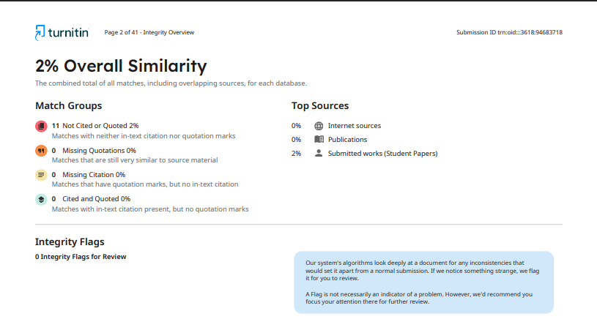

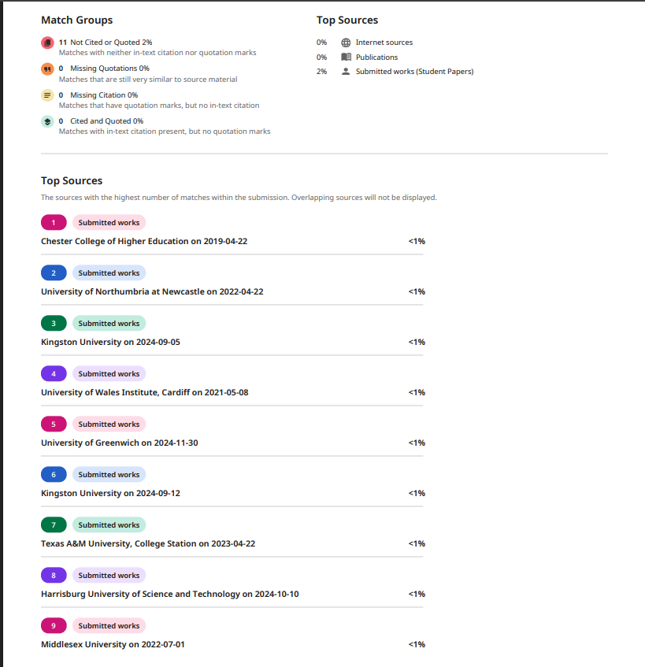

**Table of Contents**

Table of Figures 5

Introduction 8

Project Title 9

Aim of the project 9

Objectives 10

Unique Selling Point 11

Gantt Chart 12

Project Planning and Production Phases 14

Phase 1 - Planning and Research 14

Competitor Analysis 14

User Persona 29

Information Architecture 32

Scope of the Project 33

Functional Specifications 35

Phase 2 – Wireframes 37

Phase 3 – Branding 46

Brand Identity 46

Logo 47

Font 48

Color Palette 49

Graphic Designing 55

Phase 4 – Design 56

Low Fidelity 56

High Fidelity 66

Phase 5 – Prototyping 81

User Testing and Findings 83

Survey Result 85

Survey Insights 97

Evaluation 99

Self- Evaluation 99

Third-Party Evaluation 100

Conclusion 103

Bibliography 104

Appendix 105

# Table of Figures

Figure 1 Gantt Chart 12

Figure 2 GeoKrishi Website 14

Figure 3 GeoKrishi Website 2 15

Figure 4 GeoKrishi Website 3 16

Figure 5 Agri Webb Website 17

Figure 6 Agri Webb Website 2 18

Figure 7 Agri Webb Website 3 19

Figure 8 AgriBazaar Website 20

Figure 9 AgriBazaar Website2 21

Figure 10 AgriBazaar Website 3 22

Figure 11 Agrevolution 23

Figure 12 Agrevolution 2 24

Figure 13 Agrevolution3 25

Figure 14 Kisan Network 26

Figure 15 Kisan Network 2 27

Figure 16 Kisan Network 3 28

Figure 17 User Persona 1 29

Figure 18 User Persona 2 30

Figure 19 User Persona 3 31

Figure 20 Information Architecture- Agribaato 32

Figure 21 Homepage Wireframes 37

Figure 22 Marketplace Wireframes 38

Figure 23 Marketplace Wireframe 39

Figure 24 Post a bid Wireframe 40

Figure 25 Marketprices Wireframes 41

Figure 26 Bidding Wireframes 42

Figure 27 Resources Wireframes 43

Figure 28 About us Wireframes 44

Figure 29 User Dashboard Wireframes 45

Figure 30 AgriBaato Logo 47

Figure 31 Typography 48

Figure 32 Colour palette 49

Figure 33 Color Palette 1 50

Figure 34 Color Palette 2 51

Figure 35 Color Palette 3 52

Figure 36 Color Palette 4 53

Figure 37 Color Palette 5 53

Figure 38 Color Palette 6 54

Figure 39 Graphic Designing 55

Figure 40 Graphic Designing 2 55

Figure 41 Homepage Low Fidelity 57

Figure 42 Marketplace Low Fidelity 58

Figure 43 Bidding Low Fidelity 59

Figure 44 Marketplace Low Fidelity 60

Figure 45 Post a bid Low Fidelity 61

Figure 46 Marketplaces Low Fidelity 62

Figure 47 Resources Low Fidelity 63

Figure 48 About us Low Fidelity 64

Figure 49 Sign in Low Fidelity 65

Figure 50 Home Page High Fidelity 67

Figure 51 Marketplaces High Fidelity 68

Figure 52 Marketplace High Fidelity 2 69

Figure 53 Marketplace High Fidelity 3 70

Figure 54 Marketplace High Fidelity 4 71

Figure 55 Bidding Page 72

Figure 56 Bidding Page (Seller view) 73

Figure 57 Bidding Page (Trader View) 74

Figure 58 post a bid 75

Figure 59 Marketprices high fidelity 76

Figure 60 resources high fidelity 77

Figure 61 About Us High Fidelity 78

Figure 62 SignIn / LogIn 79

Figure 63 Dashboard High Fidelity 80

Figure 64 Prototyping 81

Figure 65 Prototyping 2 82

Figure 66 Survey Responses Name List 85

Figure 67 Survey Responses Name List 2 86

Figure 68 Survey Responses Name List 3 86

Figure 69 Questionnaire 1 87

Figure 70 Questionnaire 2 87

Figure 71 Questionnaire 3 88

Figure 72 Questionnaire 4 88

Figure 73 Questionnaire 5 89

Figure 74 Questionnaire6 89

Figure 75 Questionnaire 7 90

Figure 76 Questionnaire 8 90

Figure 77 Questionnaire 9 91

Figure 78 Questionnaire 10 91

Figure 79 Questionnaire 11 92

Figure 80 Questionnaire 12 92

Figure 81 Questionnaire13 93

Figure 82 Questionnaire 14 93

Figure 83 Questionnaire 15 94

Figure 84 Questionnaire 16 94

Figure 85 Questionnaire 17 95

Figure 86 Questionnaire18 95

Figure 87 Questionnaire 19 96

Figure 88 Questionnaire 20 96

Figure 89 Self Evaluation 99

Figure 90 Abhinav Devkota 100

Figure 91 Asuka Bhattachan 101

Figure 92 Anush Shakya 102

Figure 93 Log sheet 1 105

Figure 94 Log sheet 2 106

Figure 95 Log sheet 3 107

Figure 96 Log sheet 4 108

Figure 97 Log sheet 5 109

Figure 98 Log sheet 6 110

Figure 99 Log sheet 7 111

Figure 100 Log sheet 8 112

Figure 101 Log sheet 9 113

Figure 102 Log sheet 10 114

Figure 103 Log sheet 11 115

Figure 104 Log sheet 12 116

# Introduction

This coursework covers the entire UI/UX design process for AgriBaato, a digital platform aimed at simplifying and facilitating agricultural transactions in Nepal. This platform aims to bring together farmers, traders, cooperatives, and agribusinesses into a unified ecosystem that facilitates real-time market pricing, bidding systems, and collaboration in the marketplace. The documentation details every phase of the design journey, beginning with the choice of topic and research area, then defining user personas, pinpointing key objectives, and performing thorough product and competitor analysis. Additionally, it encompasses the utilized technologies, the planning and production stages, the development of wireframes and prototypes, as well as usability testing and assessment. This initiative highlights a design strategy centered around users, with particular attention given to navigational simplicity, accessibility, and clear service communication. To refine the final product and ensure that the platform is functional and aligns with user needs and expectations, the report includes feedback gathered from real users.

## Project Title

AgriBaato: A UI/UX Design for a Digital Agricultural Platform

A digital solution that connects farmers, traders, and agribusinesses using real-time pricing, a transparent bidding system and an easy-to-use marketplace to improve and streamline agricultural trading.

## Aim of the project

The aim of this project is to study, design, and create a user-centric UI/UX prototype for AgriBaato, a digital platform that fills current gaps in Nepal's agricultural trade system. The platform aims to address real-world difficulties encountered by farmers, such as limited access to fair pricing, a lack of direct market connectivity, and difficult selling processes, by building a centralized online environment where:

* Farmers can examine current market values and list their produce for sale or bidding.
* Traders and cooperatives can bid transparently and participate in bulk transactions.
* Both sides can communicate directly, which increases trust, efficiency, and profit margins.

The project's goal is to promote digital inclusion in the agriculture sector by ensuring that even rural users with rudimentary digital literacy can easily traverse the platform due to its intuitive interface, multilingual support, and mobile-friendly design. Finally, the platform empowers users, lowers middleman exploitation, and strengthens Nepal's agricultural economy.

## Objectives

The main objective of this project is to create a simple and effective UI/UX for AgriBaato, an online platform that connects farmers and traders in Nepal to simplify agricultural transactions. This project seeks to address real-world agricultural market concerns such as lack of transparency, limited accessibility, and ineffective pricing negotiation mechanisms by developing a user-friendly digital solution.

**Key UX objectives**:

User-Centered Design: Make sure the platform is easy to access and useable for both farmers and traders, considering their individual goals, needs, and levels of digital proficiency.

Improve Market Transparency: Enable real-time pricing, product listings, and bid-based transactions to help with decision-making.

Reduce Complexity: Provide simple navigation, clear forms, and visual signals that direct the user through the platform without confusion.

Promote Efficiency: Simplify the bid-posting process and ensure a smooth checkout experience for one-click purchases.

## Unique Selling Point

AgriBaato stands out as a dual-platform solution created expressly to address Nepal's fragmented and inefficient agriculture economy. It stands out for its dedicated features for farmers and traders, which combine real-time market information, a bidding system, and an interconnected e-commerce environment under one digital roof.

Unique Selling Point: Up-to-date crop pricing data enables users to make informed selling or buying decisions, increasing transparency.

Bidding System for Bulk Deals: A dynamic auction-style system that allows farmers to post crops and get many offers from traders, allowing them to choose the best price.

One-Click Marketplace: A quick and filterable purchasing alternative for customers and traders looking to buy fruits, grains, and vegetables right now.

Local Agricultural Focus: Designed exclusively for Nepal's agricultural sector, featuring native crops, vernacular labels, and regional transaction logic.

Visual and interactive UX: User dashboards provide a more current and immersive interface experience.

This platform is about more than just buying and selling; it's about empowering the hands that feed the nation by providing better digital tools for growth, negotiation, and prosperity.

# Gantt Chart

Our Gantt chart shows how the AgriBaato UI/UX design project has 24 weeks of tasks that start with research preparation and finish with the final submission. During the first three weeks researchers studied markets and users to collect data from relevant business websites. The design team created our sitemap during this phase.

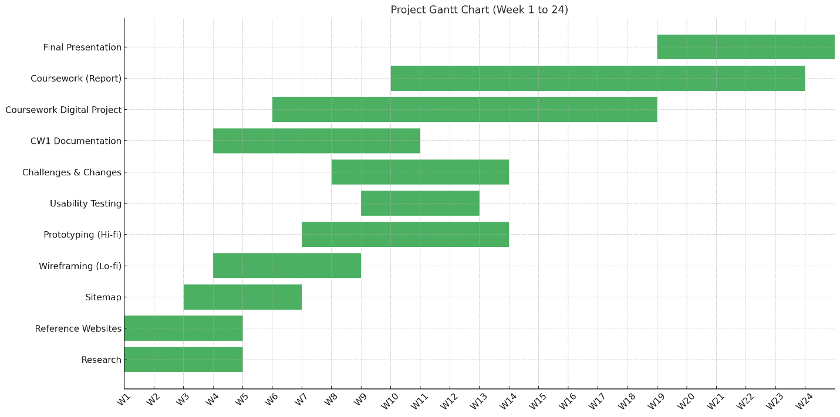

Figure 1 Gantt Chart

During Phase 2 from Week 4 through Week 8 developers worked on UX projects that started with wireframe creation then advanced to high-fidelity prototype creation. While setting up the type and colors we began working on basic user interface looks.

During Week 9 through Week 11 design polish took precedence while UI designers created detailed screens and tested appearance consistency within the team. During Phase 4 at Weeks 12 through 14 our team built digital mockups and prototypes then made them work interactively.

The testing and evaluation work took place between weeks 15 and 18. People tested our system for user experience while we gathered their opinions. Our team of testers (one girl and two boys) tested our design while we assessed it ourselves. Our team updated the work based on feedback from users.

During Phase 6 (Week 19–21) I produced the coursework documentation (CWI) which outlined every obstacle and modification we made across the project.

During the seven-day final phase students compiled their presentation materials for submission. To plan for unexpected problems a buffer week was added to the completion date. Through the Gantt chart our team kept track of productivity and achieved design goals on schedule.

# Project Planning and Production Phases

## Phase 1 - Planning and Research

### Competitor Analysis

#### GeoKrishi

Focus: An agricultural decision-support tool for Nepali farmers (planning, weather, and input tracking).

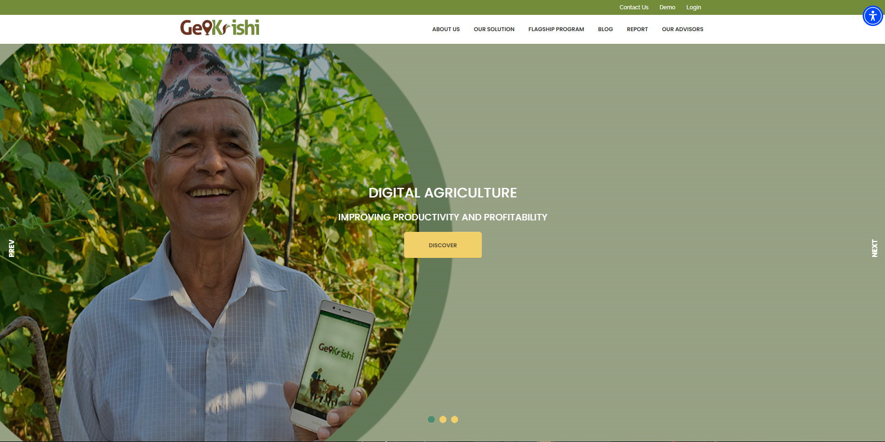

Figure 2 GeoKrishi Website

**Good Points:**

* Expert knowledge of all aspects of Nepal's agricultural sectors.
* Employs local experts plus temporary scheduling with climate predictions.
* Our platform communicates exclusively in Nepali language.

**Bad Points:**

* Limited trading options, largely for informational purposes.
* The website's design does not accommodate small displays.
* The images are out of date, and the iconography is inconsistent.

**Analysis:**

GeoKrishi helps farmers through advisories without providing them with opportunities to connect to markets. The system concentrates on farm practices instead of marketplace activity.

**Implementation for AgriBaato:**

* Join province or district filtering data to help users explore local information.
* Take inspiration from crop calendars today so we can add them later as an optional feature.
* Place modern visual design first and build trading tools starting from buying and selling.

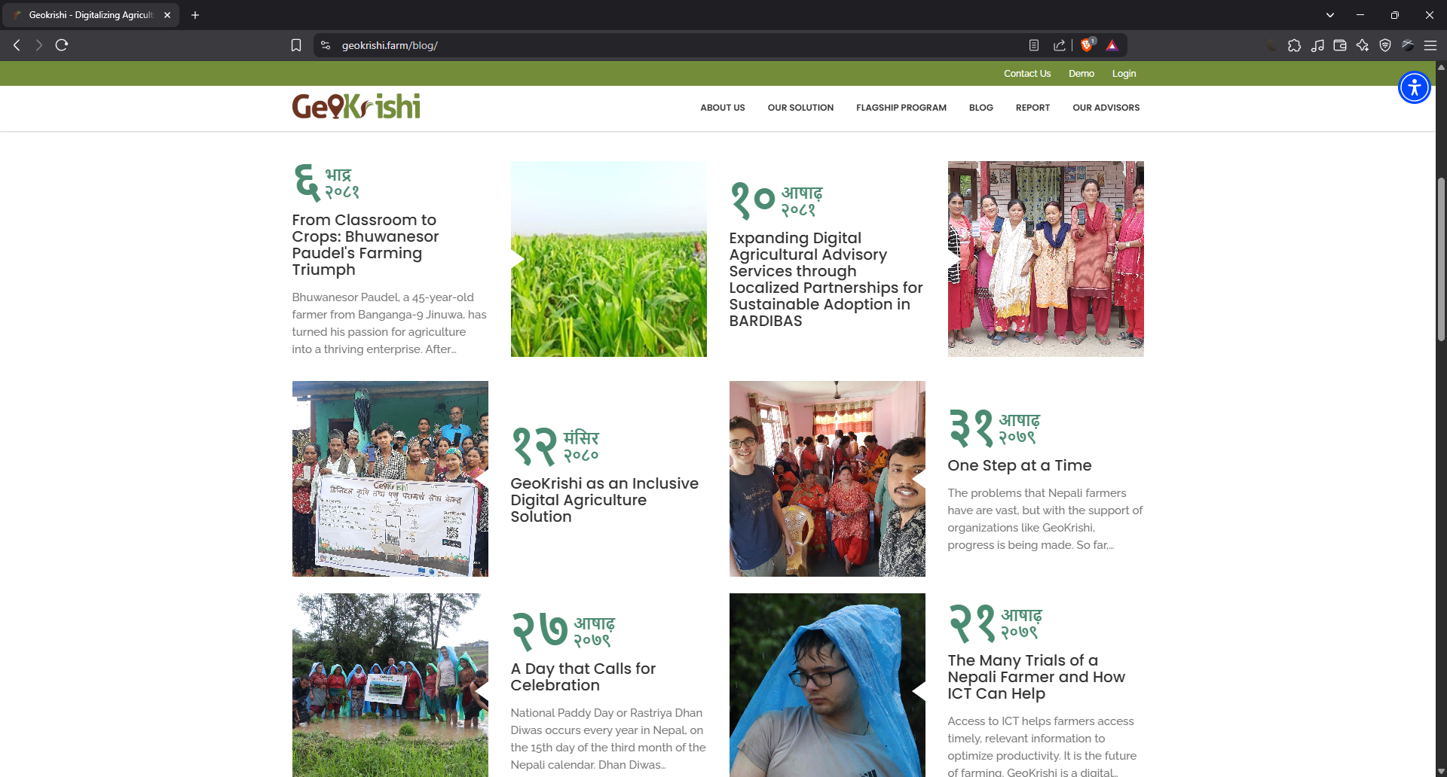

Figure 3 GeoKrishi Website 2

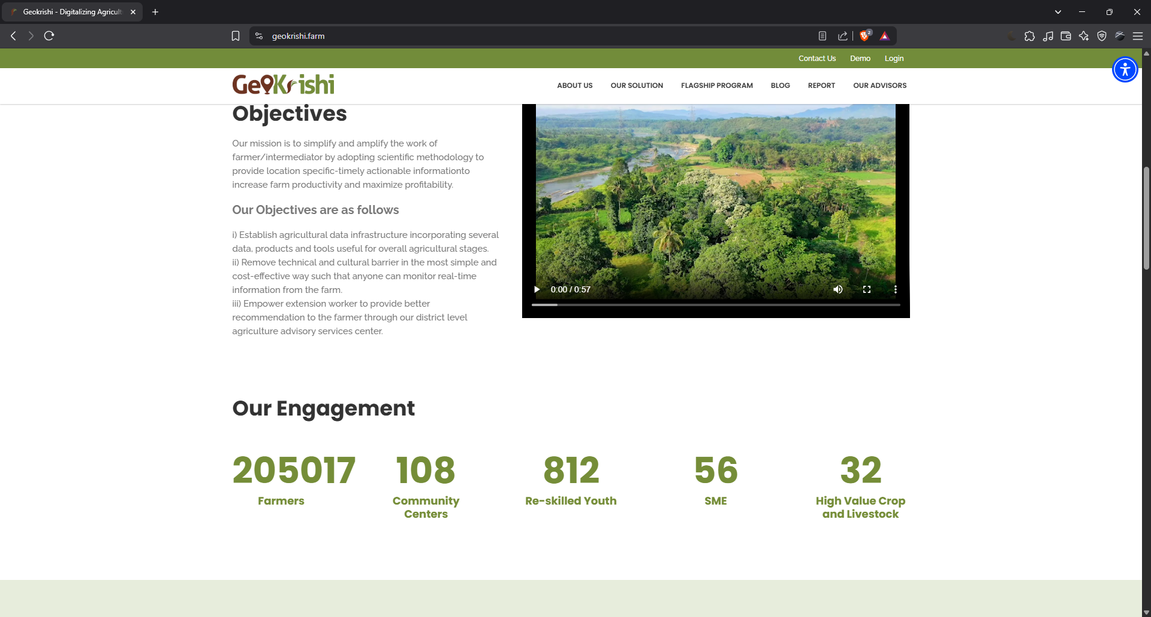

Figure 4 GeoKrishi Website 3

#### Agri Webb

Focus: Commercial farms can benefit from digital farm and livestock management software.

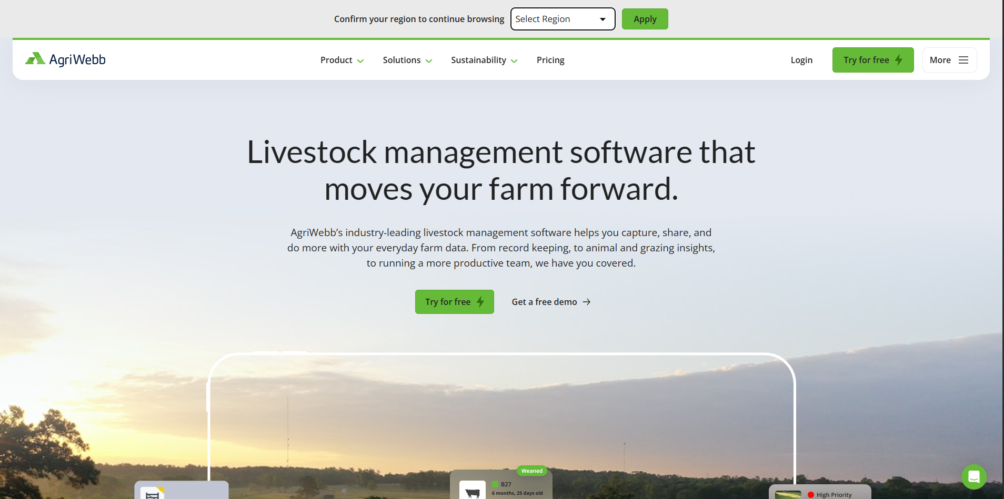

Figure 5 Agri Webb Website

**Good Points:**

* Excellent data management dashboards.
* It allows you to capture data offline.
* Let’s keep detailed farm operations in a simple daily journal.

**Bad Points:**

* Too complex for small farmers.
* The system prioritizes livestock information which is not beneficial for farmers who only grow crops.
* Market leaders designed their platform primarily for enterprise use, but it remains beyond rural users who lack technical training.

**Analysis:**

Agri Webb’s powerful functions do not match the needs of crop-farming small farmers in Nepal. The registrar on data will supply information for future visualization needs.

**Implementation for AgriBaato:**

* In future releases we will build a lightweight dashboard to present essential farm data including price records, sales performance and winning auctions.
* Design a simple interface that shows visual information to prevent an overloaded display of data.

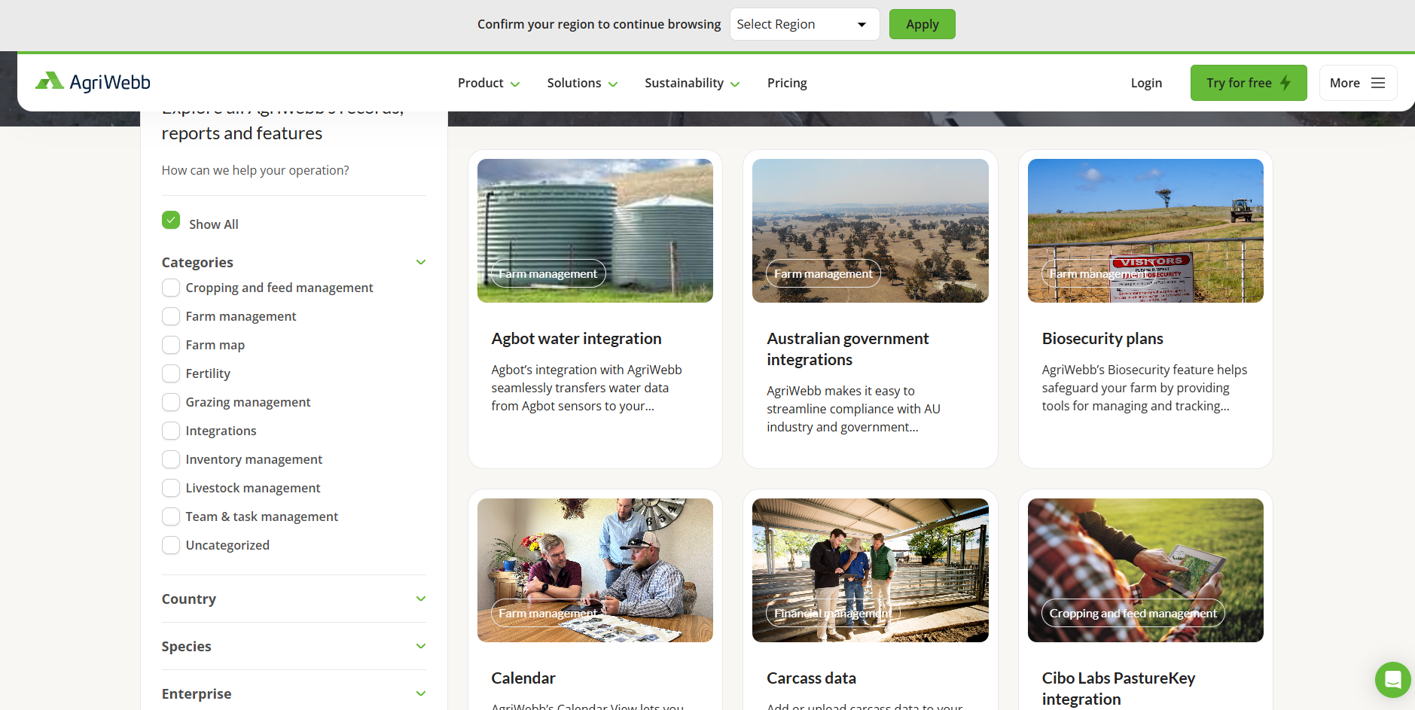

Figure 6 Agri Webb Website 2

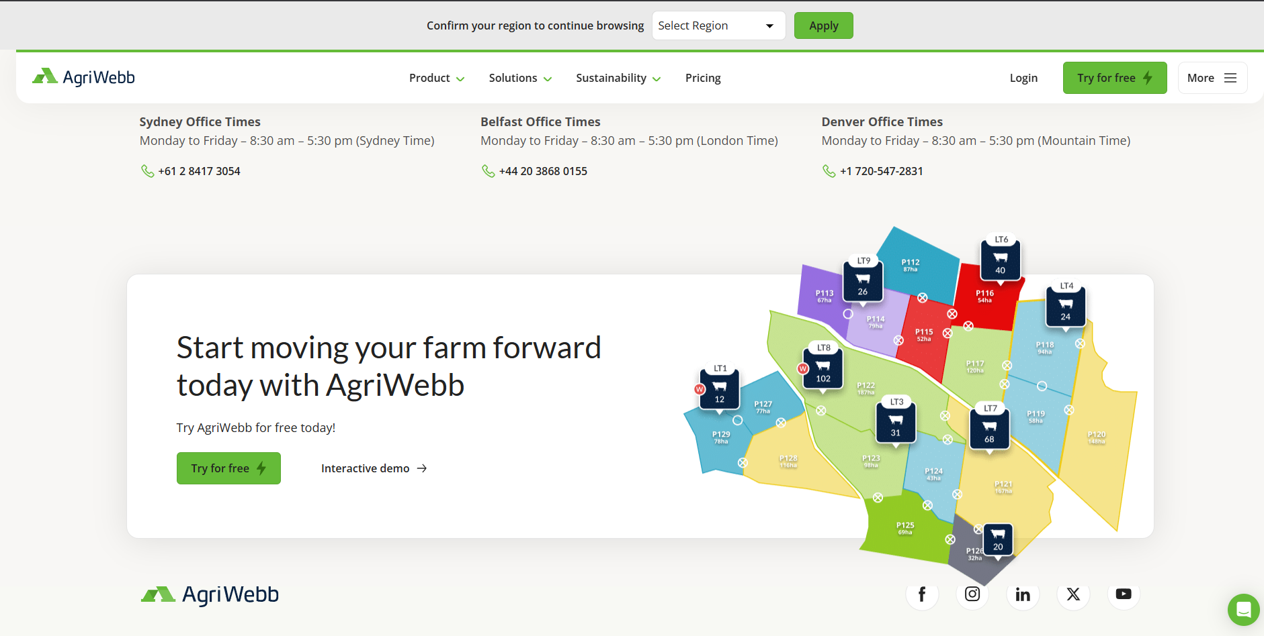

Figure 7 Agri Webb Website 3

#### AgriBazaar

Focus: A B2B agri-trading platform that enables farmers and buyers to transact in huge quantities.

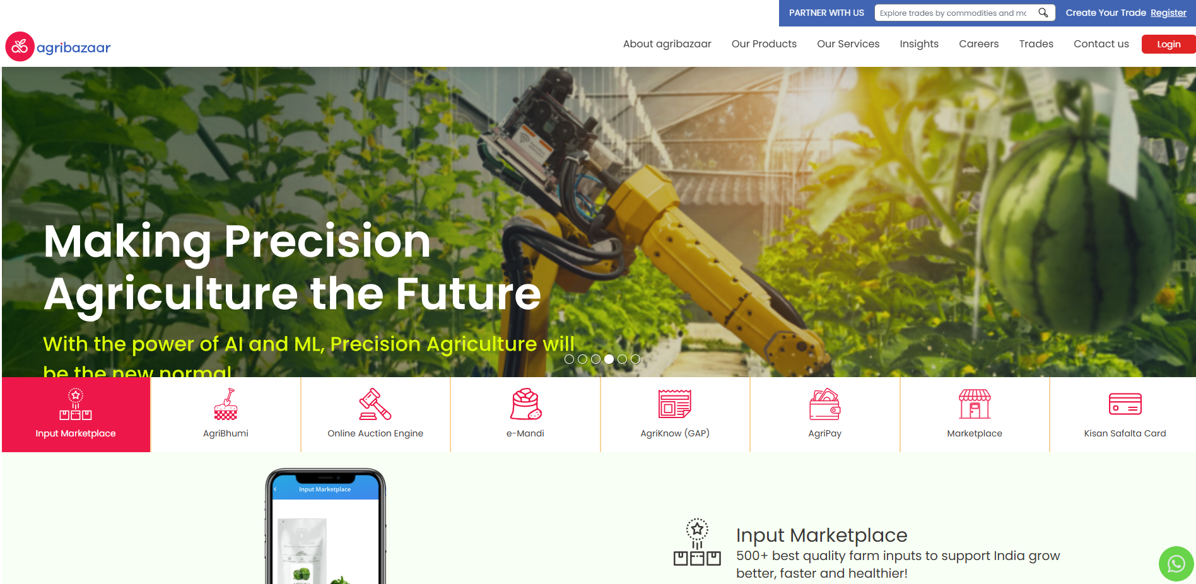

Figure 8 AgriBazaar Website

**Good Points:**

* The marketplace features a clear bidding setup that shows the starting price and top bid updates plus time left.
* Buyers can do advanced property searching through Location, Pricing, Crop types and Seller Rating.
* Seller verification increases buyer trust.
* Notification system for bidding alerts.

**Bad Points:**

* The website display contains too many text elements and tiny hard-to-read letters in one space.
* The system needs too many scripts making pages slow to load.
* It does not work well for people who want to shop by looking at pictures.

**Analysis:**

AgriBazaar successfully handles large-scale transactions while struggling to create an easy-to-understand user interface. Users can take advantage of many functions yet find the platform hard to use at the beginning.

**Implementation for AgriBaato:**

* Simplify the bidding UI with huge cards by cropping the image, quantity, base price, and timing.
* Keep the trader dashboard clean with real-time updates and distinct tabs for "Active Bids" and "Won Bids."
* Set up a review/rating system for dealers and farmers.

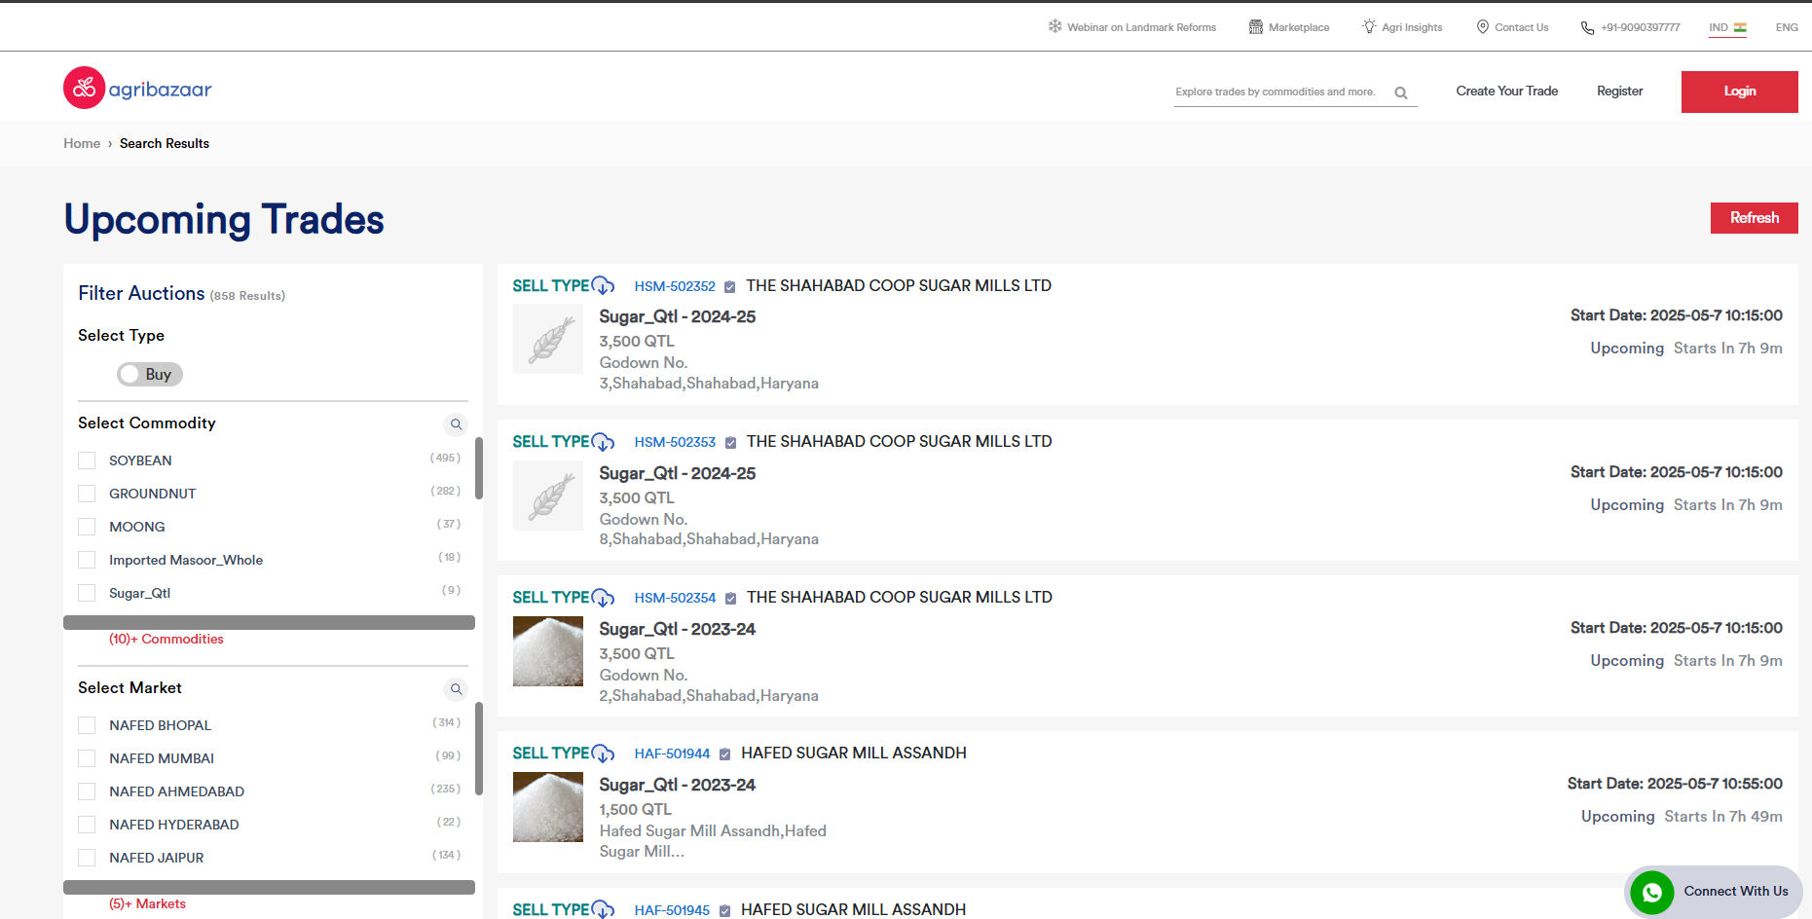

Figure 9 AgriBazaar Website2

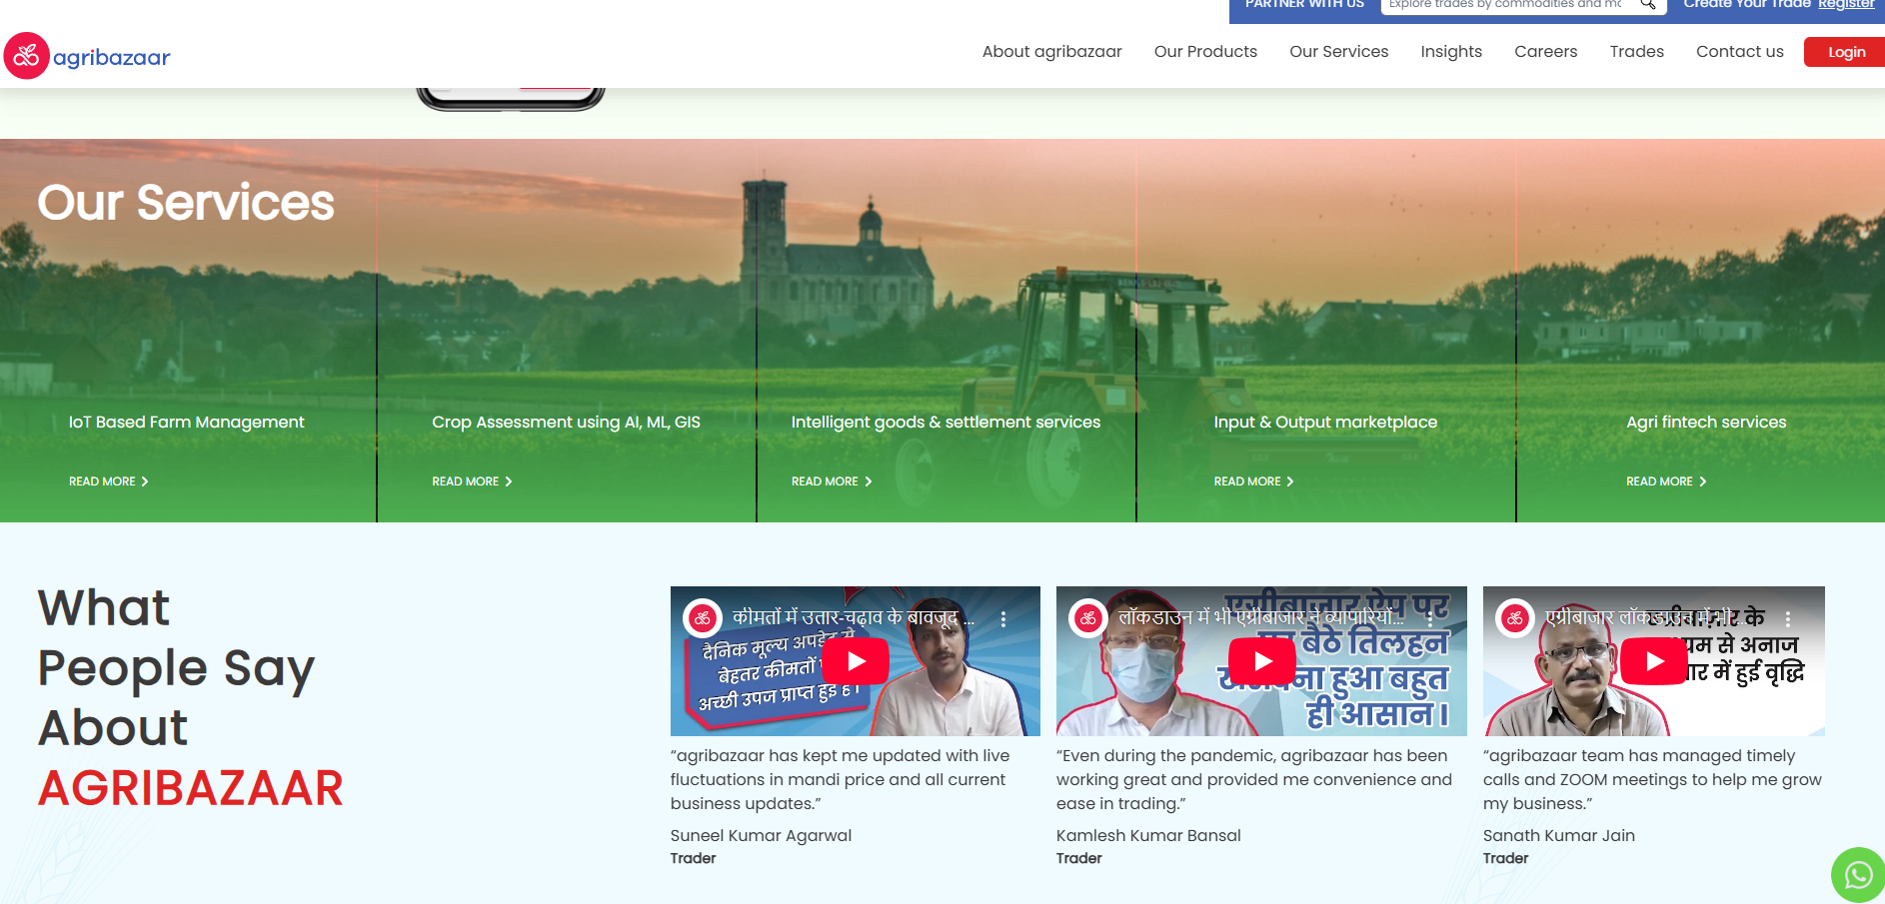

Figure 10 AgriBazaar Website 3

#### Agrevolution

The focus is on an integrated farming ecosystem that includes input supply, consultancy, financing, and market access.

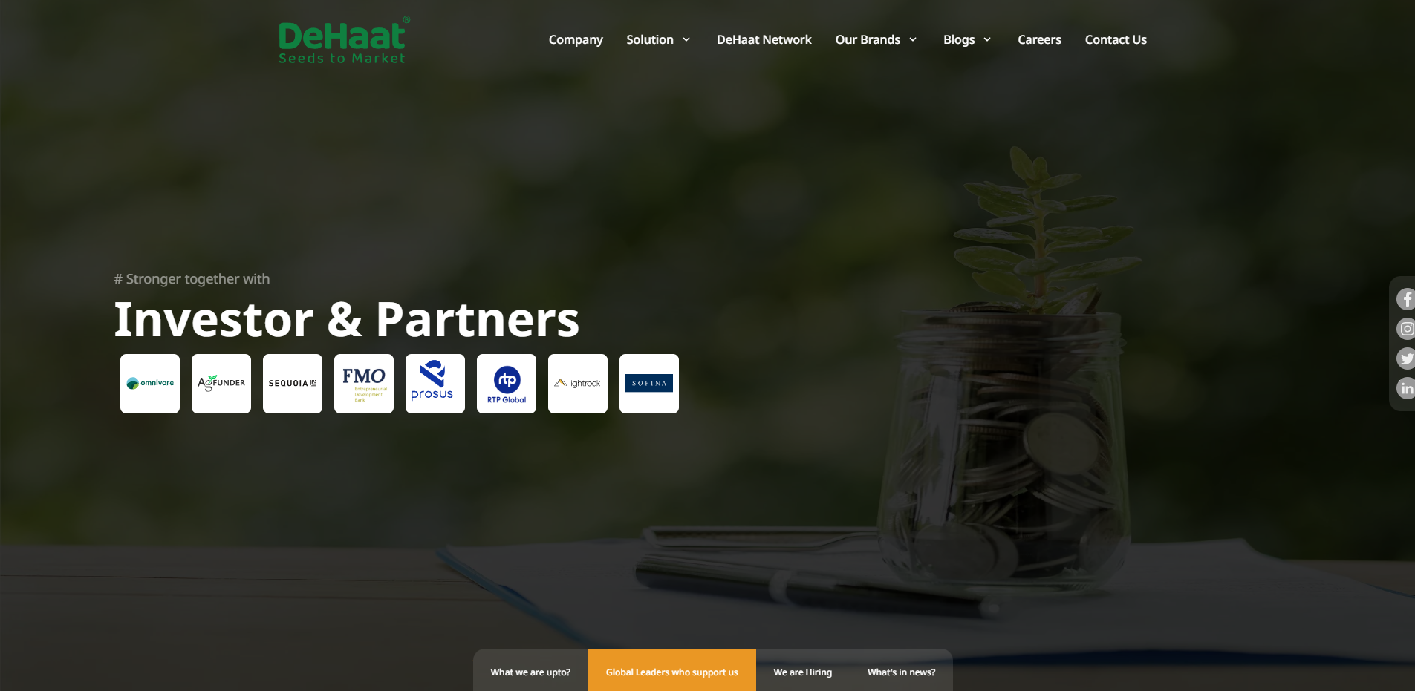

Figure 11 Agrevolution

**Good Points:**

* Provides many service types under one easy-to-use system.
* Our brand design presents a clean look with clear service areas.
* Our design works with any screen size and our mobile version looks easy to use.
* Our system gives farmers seasonal and regional recommendations about their selected crops.

**Bad Points:**

* User experience becomes hard to navigate when multiple functions are placed together.
* Homepage lacks clarity; New users find it hard to determine which screen they should begin looking at first.
* Trader-side experience is less emphasized.

**Analysis:**

The Agrevolution package serves all your needs, yet its complexity can be hard to navigate. The main page presents content that serves multiple types of users at the same time.

**Implementation for AgriBaato:**

* Design an independent navigation path for users of both Portals.
* During Phase 1 we launch our marketplace and bidding capabilities without extra services.
* Follow our branding patterns but simplify written information.

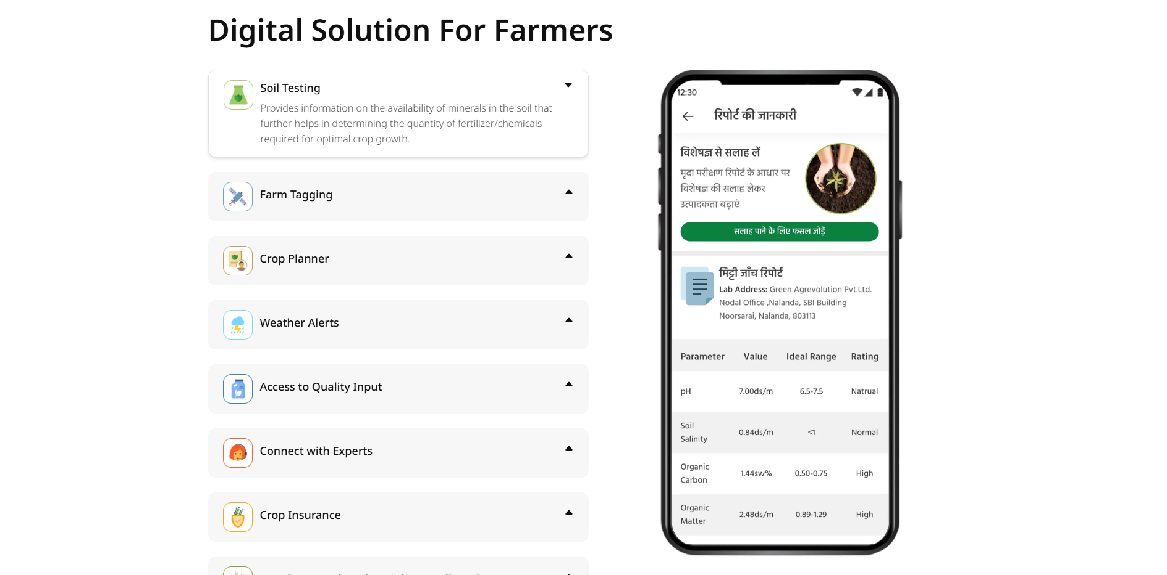

Figure 12 Agrevolution 2

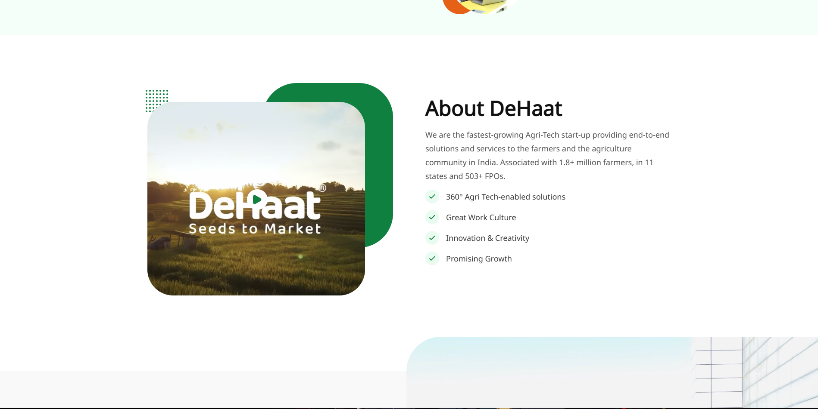

Figure 13 Agrevolution3

#### Kisan Network

Focus: Farmers receive comprehensive supply chain support, including logistics, digital payments, and buyer networks.

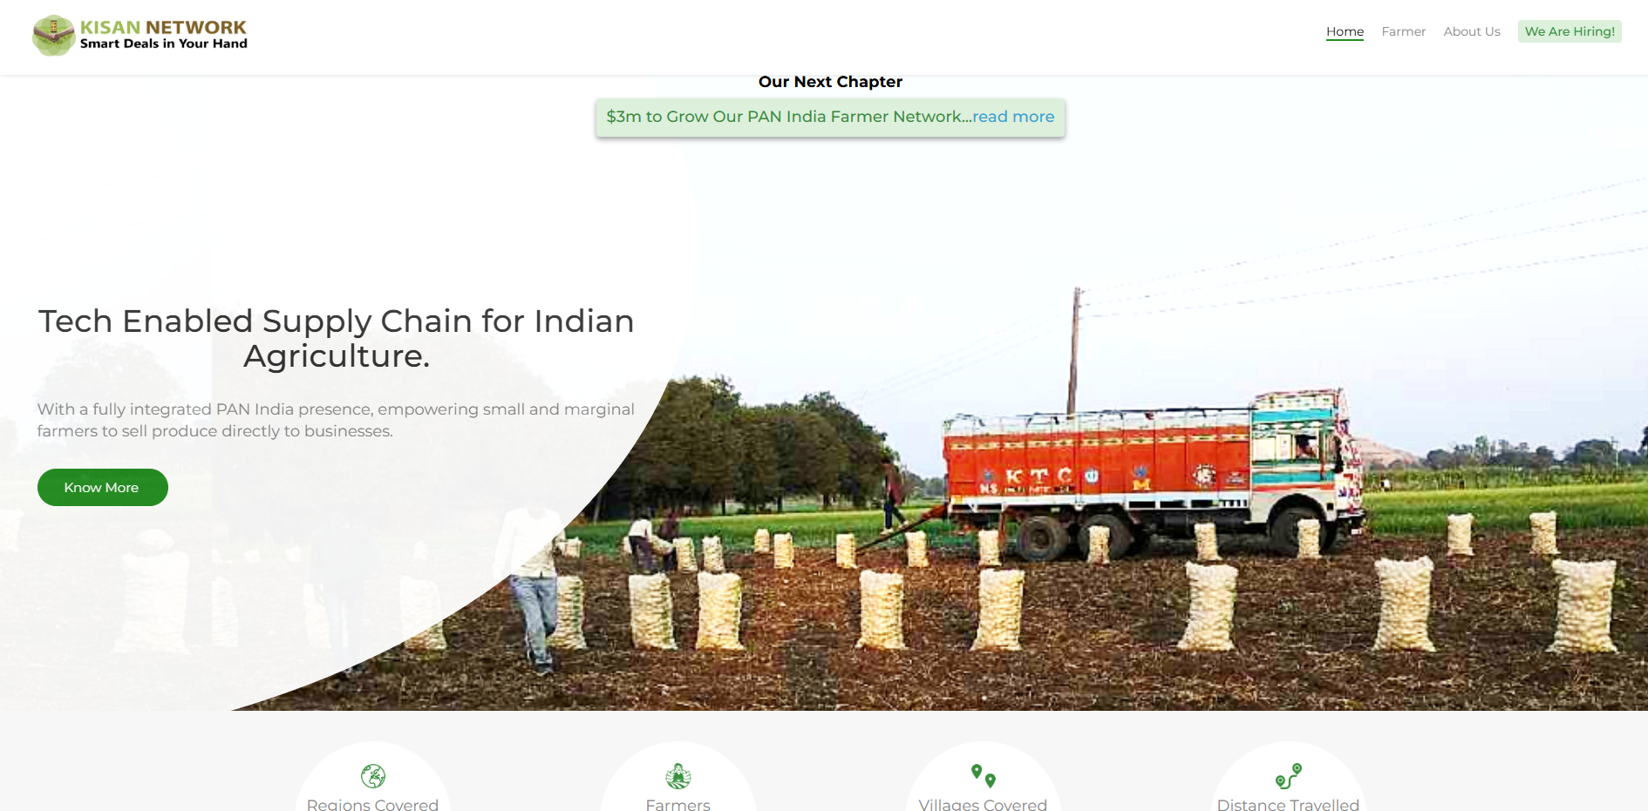

Figure 14 Kisan Network

**Good Points:**

* Our system enables rural users to work with their preferred local and regional languages.
* Our platform includes comprehensive back-end features for logistics and online payments built as a natural part of the system.
* Our basic text-based layout functions perfectly across slow internet connections.
* Provides a mobile first experience.

**Bad Points:**

* The system displays information without exciting product visuals that make users want to interact.
* Basic platform tools need a user account to use them.
* The crop details appear as dense text without useful charts or icons.

**Analysis:**

The Kisan Network system places more importance on working behind the scenes than in clearly presenting content to users. Its success comes from technical backbone improvements not public interaction or design openness.

**Implementation for AgriBaato:**

* Users should get to see crops before they need to register as guests.
* Display crop listings with images and prices through easy-to-read product cards.
* Switch to pre-populated drop-down menus to let users select information faster. For instance, districts and crop varieties.
* Rephrase the following sentence. Make sure the website operates properly on weak internet connections in rural Nepal.

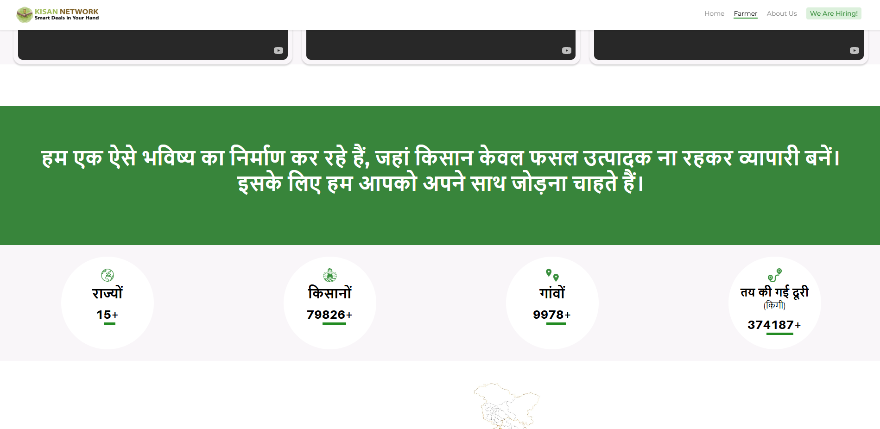

Figure 15 Kisan Network 2

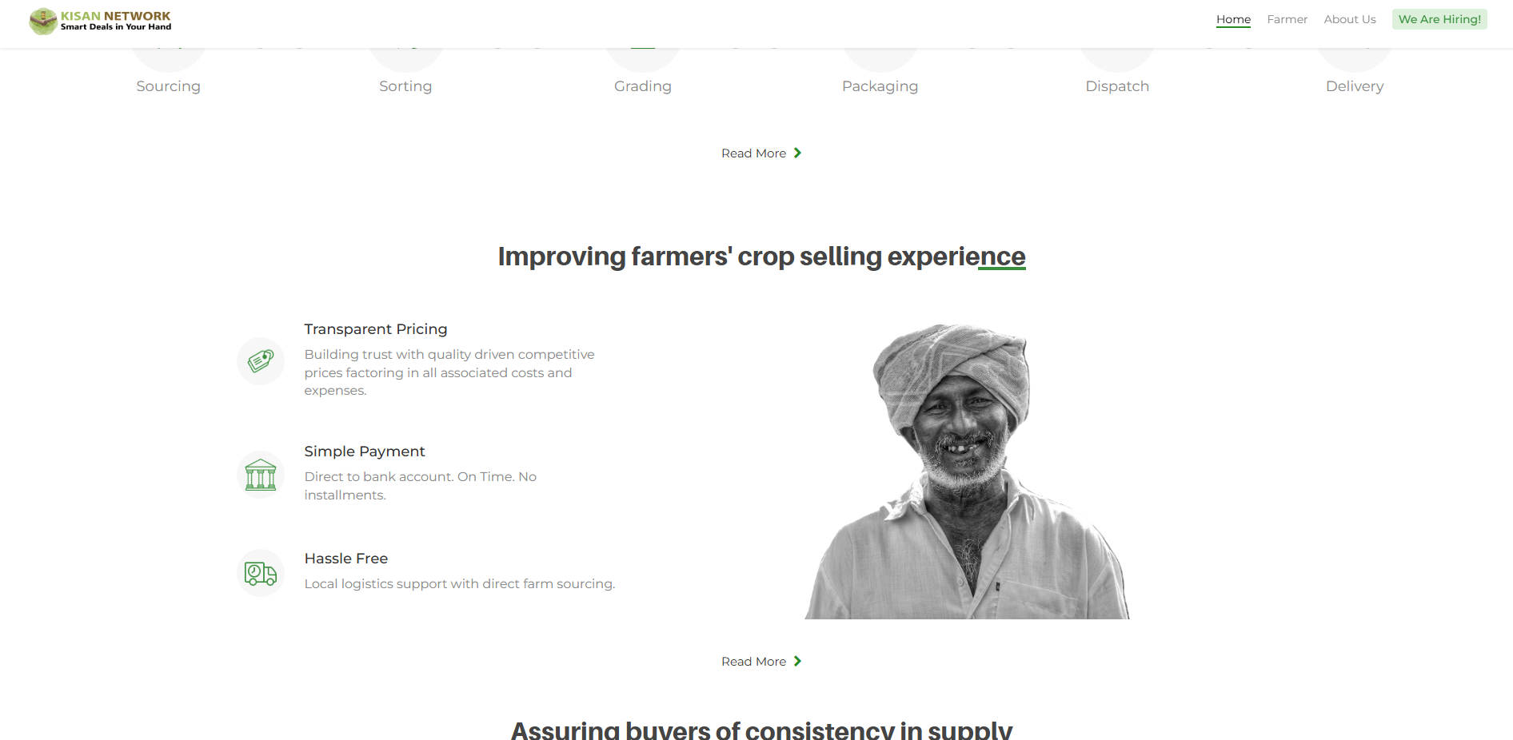

Figure 16 Kisan Network 3

### User Persona

A fictional, in-depth depiction of a typical user or user segment for your platform is called a user persona. To create a more user-centered experience, UI/UX designers utilize it to gain a deeper understanding of user demands, habits, goals, and pain areas.

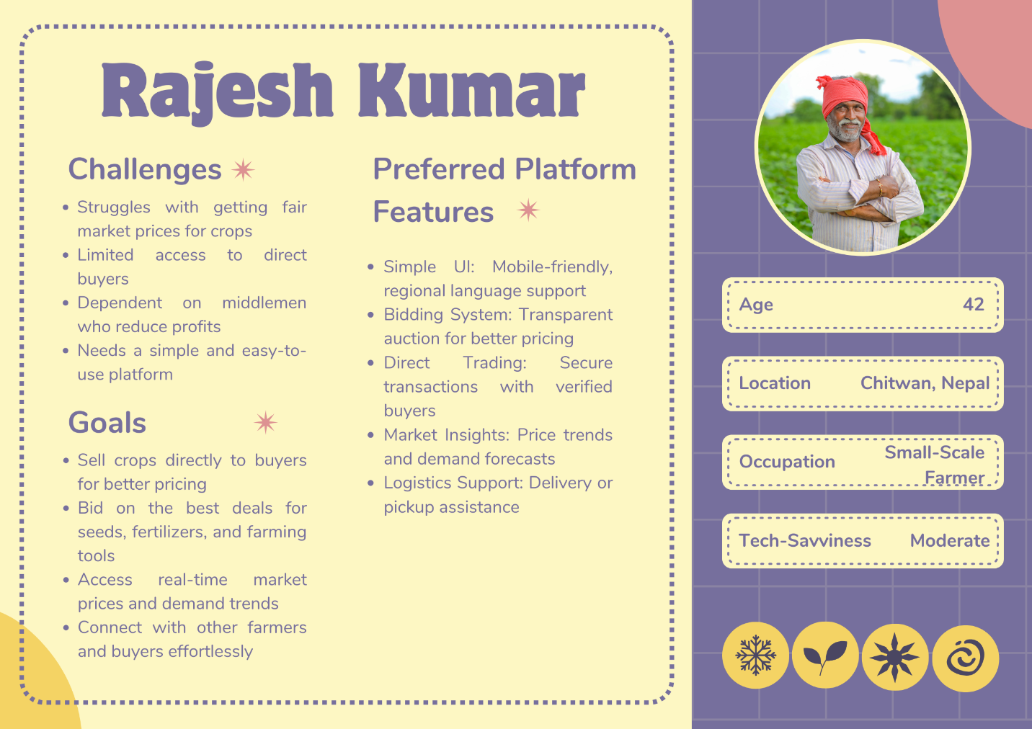

Figure 17 User Persona 1

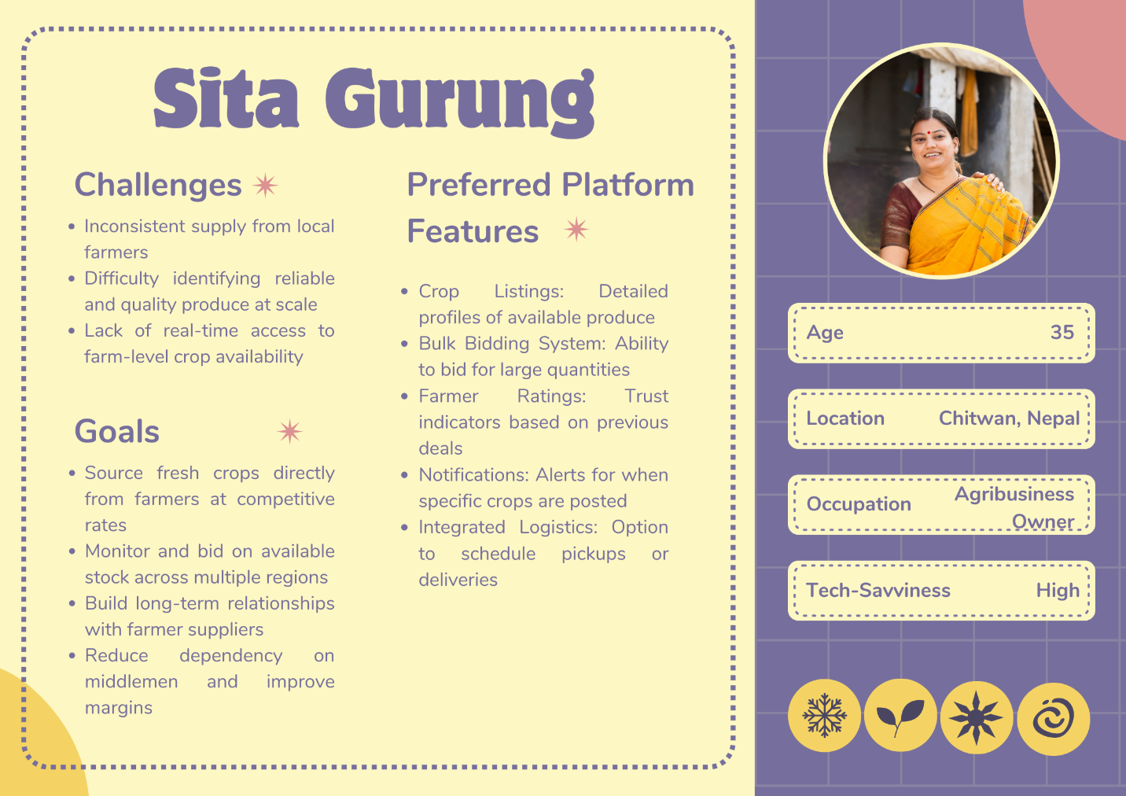

Figure 18 User Persona 2

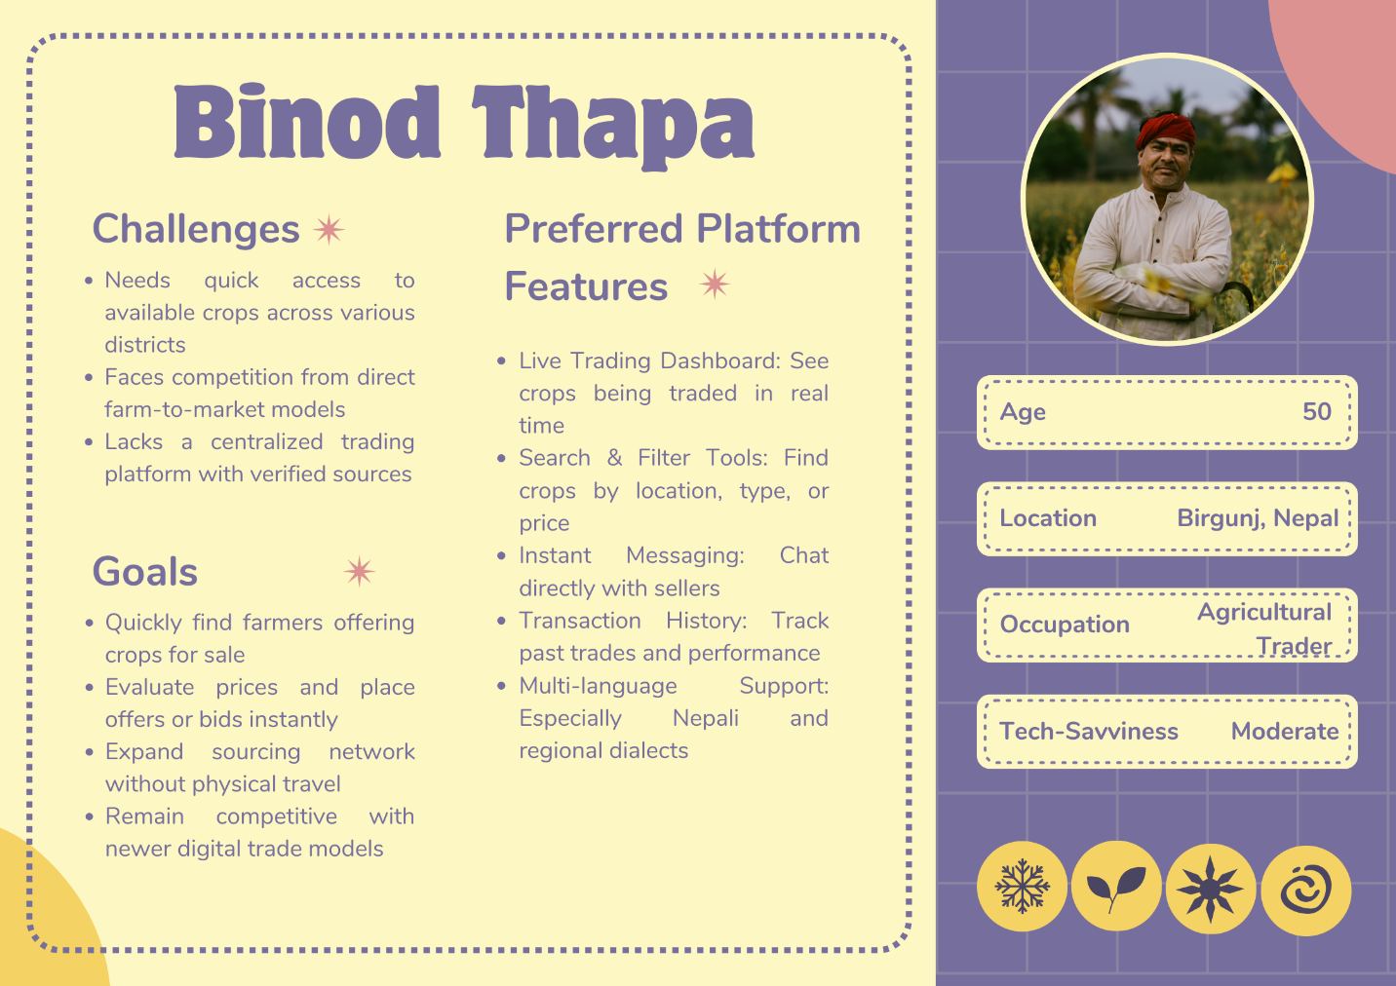

Figure 19 User Persona 3

### Information Architecture

Information Architecture (IA) describes how the product's information and features are logically arranged and browsed. AgriBaato's IA was developed with clarity, simplicity, and role-specific flows for farmers and traders, providing ease of use and little cognitive strain.

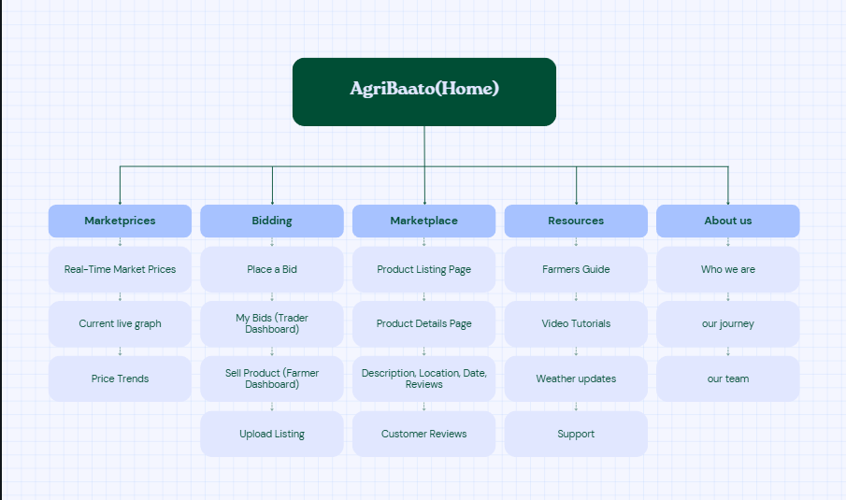

Figure 20 Information Architecture- Agribaato

### Scope of the Project

The scope shows exactly which features and capabilities AgriBaato platform includes as part of its product development. It links user requirements (Strategy) to all Information Architecture structural choices made by the team.

In-Scope Features:

The product design includes these features which we have developed for the current prototype on the desktop platform.

Core features for farmers:

* Sell Product Page - Form for entering product information (crop name, amount, location, price, harvest date).
* Manage Listings Dashboard - View, update, and delete listings.
* Bidding Participation - Advertise bulk crops and solicit bids from traders.
* Real-Time Market Pricing: View the most recent pricing for typical agricultural items.
* View Market Opportunities: Filter-based demand discovery from dealers.
* Profile management entails updating personal and farm information.

Important features for traders:

* Marketplace: Browse and filter products by region, crop kind, and price.
* Crop data, vendor information, and reviews can all be found on the product detail page.
* Bidding System - Place bids on bulk crops and track your bid history.
* Trader Dashboard - View active bids, winning bids, and buying history.
* Contact farmers - Send notifications following a successful bid or purchase.

Shared Features:

* Login/Signup Flow with Role Selection (Farmer or Trader).
* User Dashboard - Dashboards for specific roles, with sidebar navigation.
* Reviews System - Submit and read customer product reviews.
* The Help & FAQ section provides basic assistance to new users.
* Branding Consistency - A unified UI that uses the same brand color, typefaces, and logo on all pages.

Future enhancements (post-scope ideas):

* These features can be explored in future iterations if the product is developed further.
* Version is responsive and mobile-friendly.
* SMS-based login and farm notifications
* The real-time chat function
* Verified seller/trader badges.
* Price records that use blockchain technology for transparency.
* Crop calendar and weather insights

### Functional Specifications

The functional specifications of AgriBaato main outline are Home, Market Prices, Bidding, Marketplace, and Resources.

AgriBaato starts with a Home page which demonstrates to users the system's function with two defined roles: Farmers and Traders. Users can find "Post a Product," "Browse Market" and "Join as Trader" buttons on the interface. This page features information about the platform's real-time pricing capabilities alongside transparent transaction systems and bidding process along with easy navigation and login access from the simple navigation bar.

The Market Prices page shows currently active live information about market prices which is updated daily for agricultural products. Users can see data presented as tables or cards which include dynamic filters based on product type and location and date parameters. Price trends on this page are shown through visual marking elements which include curved arrows and colored indicators. Real-time data supports the system which enables traders and farmers to make informed purchase and sales decisions.

The Bidding page presents separate interfaces which serve farmers and traders. Through the form submission farmers can advertise their crops for bidding by providing crop name details and quantity information along with anticipated kilogram price and availability date as well as location and product quality and optional attachments. Following listing publication traders can access the listings to view current bids alongside possibilities to offer their prices. Users can see both base price and top bid amount while tracking the number of active offers on a listing alongside messaging capabilities for direct farmer-trader negotiations. The system creates opportunities for equitable pricing practices and active price competition.

The Marketplace page enables both traders to browse accessible crops using a searchable product display feature. Visitors viewing products will access their detailed view through a new page which shows product descriptions alongside harvest dates and locations alongside customer feedback and seller information. A simplified "Buy Now" transaction enables direct sales beyond traditional bidding procedures. The page supports quick purchases of limited quantities of smaller items.

Users can access educational information through this platform's dedicated educational hub. The page features articles combined with how-to guides along with seasonal farming tips and official government resource links. The platform uses crop types and farming topics as information categories to assist users with practice development and decision enhancement.

The website integrates consistent user features throughout all pages, allowing users to register, select their profile type, build accounts and maintain their profiles, create listings, browse offers, start messaging with other users and give ratings to transactions. Farmers maintain control of their inventory listings through the website platform to handle offers and traders directly purchase products, or place offers on the system which farmers can accept or decline. Both user types benefit from dashboards which provide easy tracking of their accessible activities.

## Phase 2 – Wireframes

Wireframing is an important component of the design process since it lays out the basic framework of the interface before going on to specific visuals. It focuses on layout, hierarchy, and functionality without visual distractions, which aids in the validation of user flow and interactions early on.

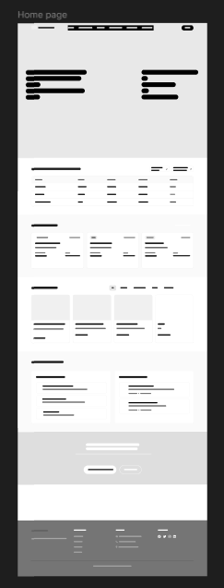

Figure 21 Homepage Wireframes

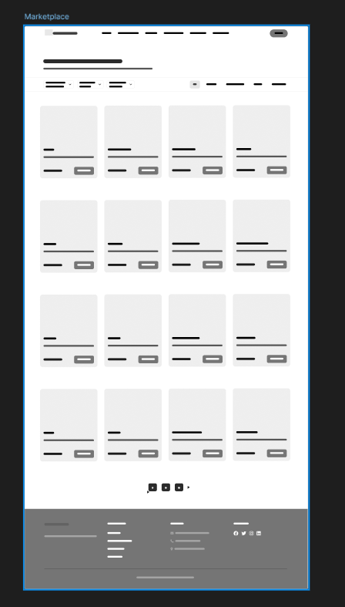

Figure 22 Marketplace Wireframes

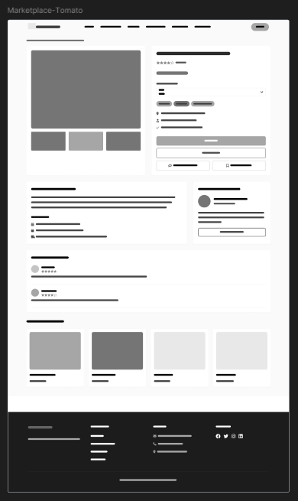

Figure 23 Marketplace Wireframe

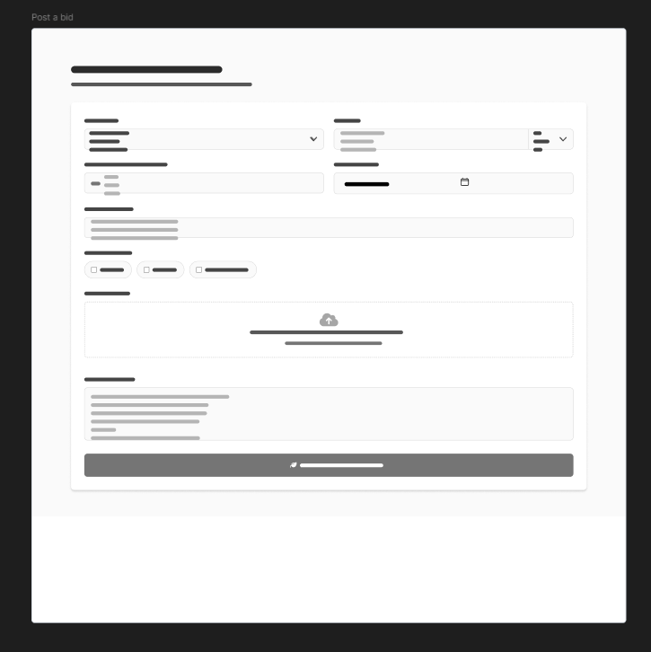

Figure 24 Post a bid Wireframe

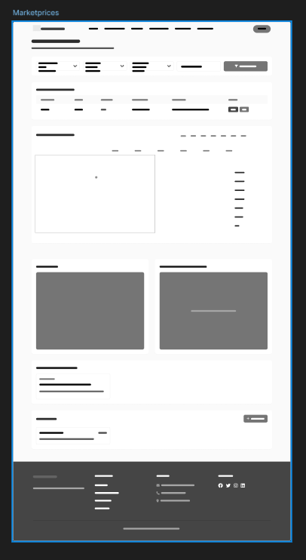

Figure 25 Marketprices Wireframes

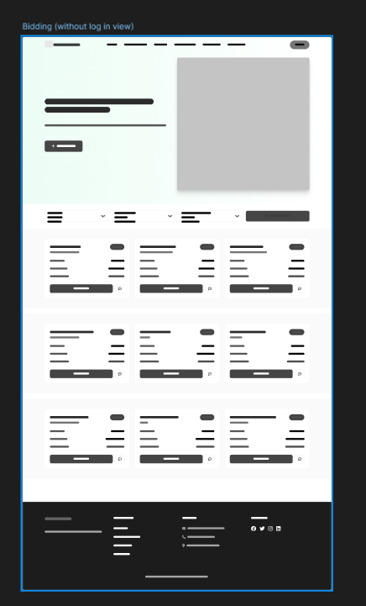

Figure 26 Bidding Wireframes

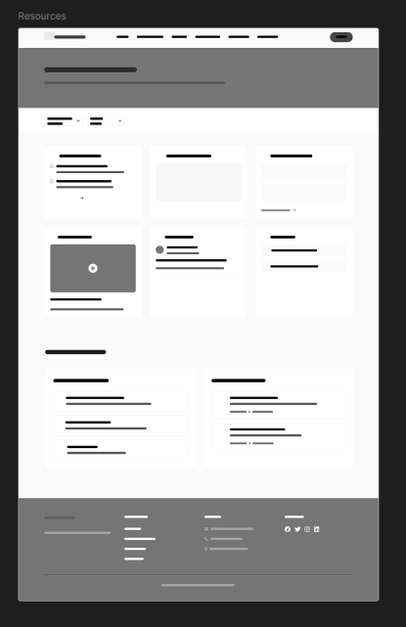

Figure 27 Resources Wireframes

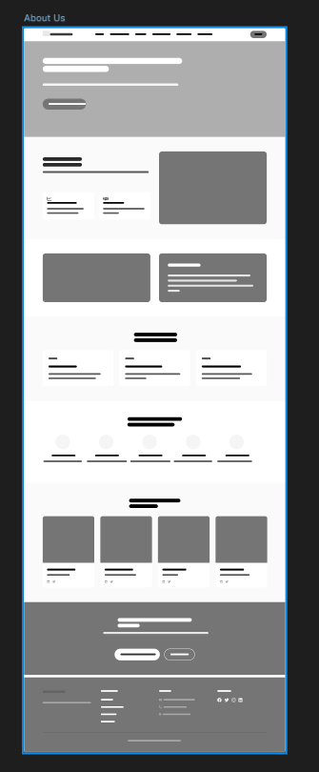

Figure 28 About us Wireframes

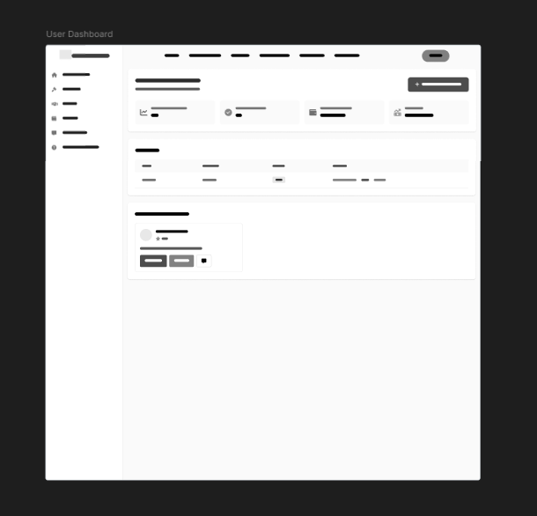

Figure 29 User Dashboard Wireframes

## Phase 3 – Branding

### Brand Identity

Our brand identity exists to make our core mission visible which is building an open digital platform for Nepalese agriculture markets. Through modern technology AgriBaato builds an open digital network that better serves Nepal's agricultural trading sector. AgriBaato was named to point farmers on the best route toward agriculture success.

As a reliable digital partner AgriBaato wants to help rural trade networks and farming communities with its warm trustworthy and enabling brand character. Our platform uses soft pleasant colors alongside straightforward layouts and simple design features that ensure everyone can navigate the system from their first visit. The design team took farm-centric themes to create UI elements that work well on digital platforms.

Our visual identity lets customers use the platform with confidence and connects established farming with today's commerce. Each aspect of our brand depicts agriculture in such a way that it builds respect for the field as it links producers to customers.

### Logo

This is the logo of AgriBaato.



Figure 30 AgriBaato Logo

### Font

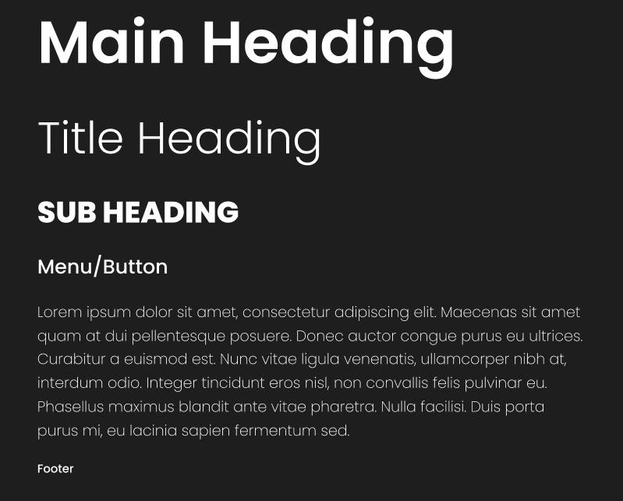

Figure 31 Typography

### Color Palette

To express the agricultural ethos while maintaining great visual clarity throughout the UI, the AgriBaato platform employs a vivid yet grounded color palette. Each color was carefully chosen to maximize user engagement and create a visually unified identity.

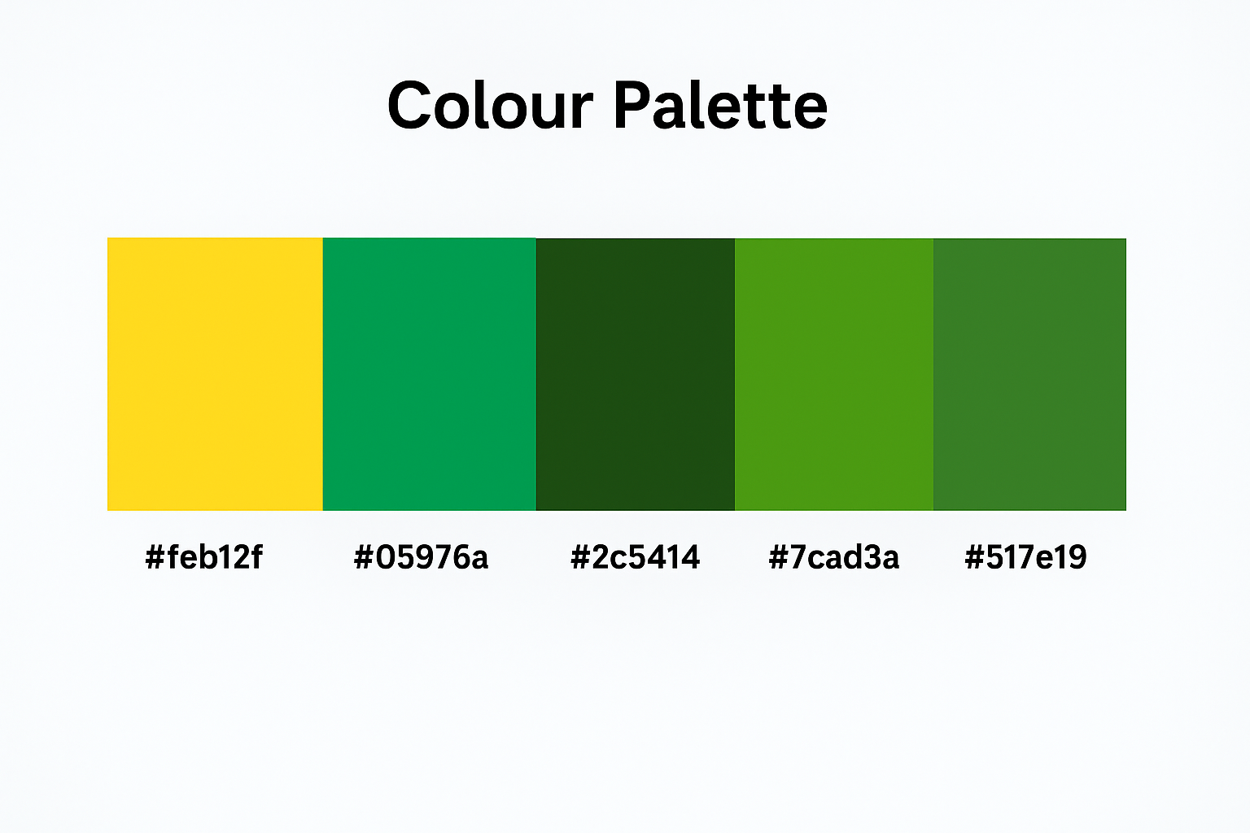

Figure 32 Colour palette

#feb12f: The site uses strong red elements for main Call to Action buttons including Login and hero section components.

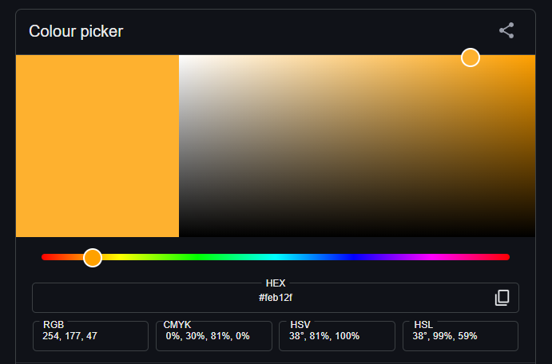

Figure 33 Color Palette 1

#05976a: Users see positive action buttons in fresh green colors that represent growth and advancement.

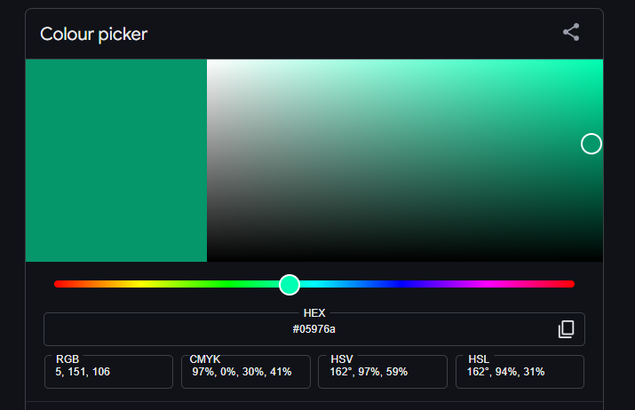

Figure 34 Color Palette 2

#2c5414, #7cad3a, #517e19: These natural green colors from agriculture stand as the base for hero section backgrounds and support UI design to make the experience feel familiar.

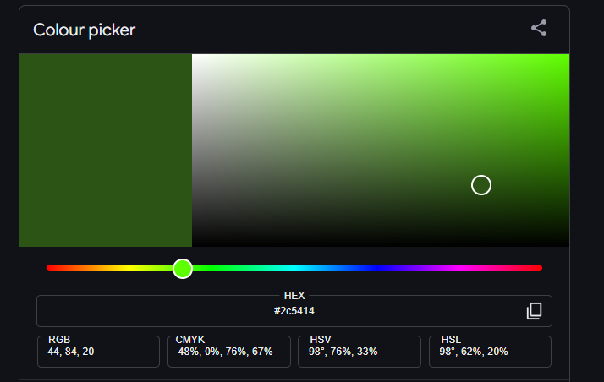

Figure 35 Color Palette 3

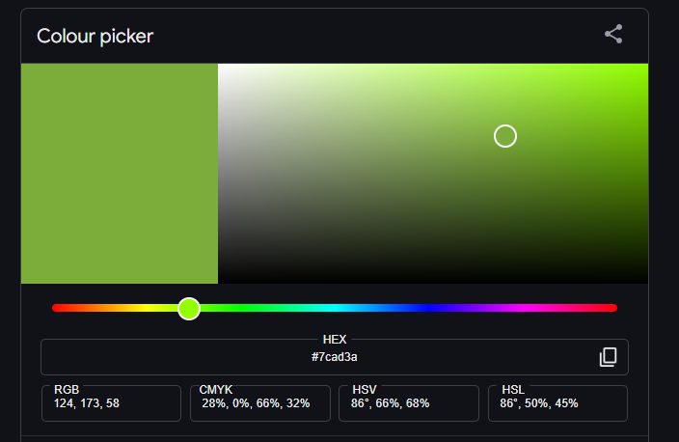

Figure 36 Color Palette 4

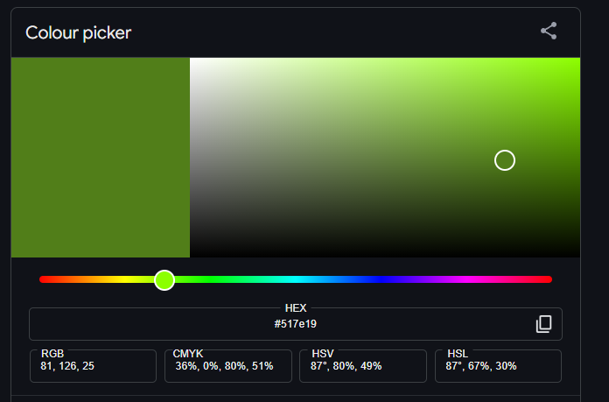

Figure 37 Color Palette 5

#e8f4ef: The background presents a smooth neutral choice that helps both contents show well and stay easy to read across all parts of the design.

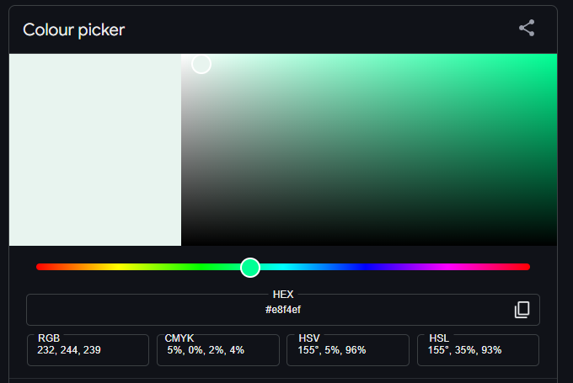

Figure 38 Color Palette 6

### Graphic Designing

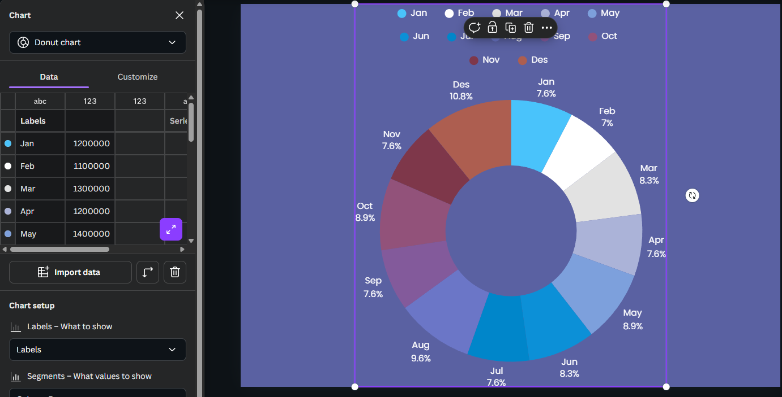

Figure 39 Graphic Designing

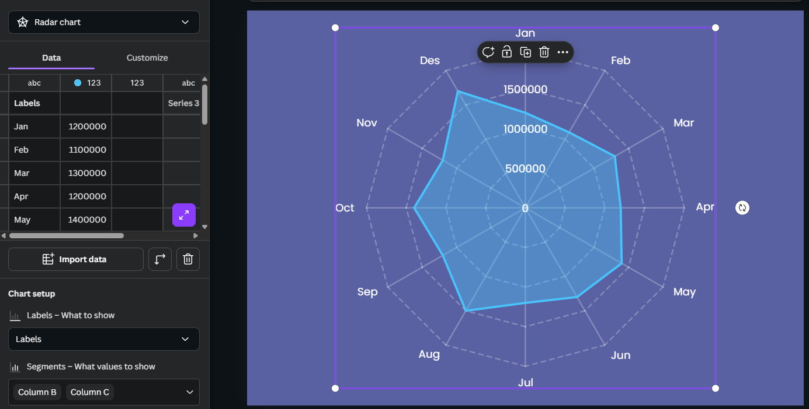

Figure 40 Graphic Designing 2

## Phase 4 – Design

### Low Fidelity

Low-fidelity wireframes were generated to lay out the basic framework of each page. These were created in grayscale to highlight layout, navigation, and utility over color and branding. Pages such as Home, Marketplace, Bidding System, Resources, Login/Signup, and User Dashboard were designed with a focus on straightforward navigation, content arrangement, and user flow. Before moving forward with comprehensive design, these wireframes assisted in identifying usability issues.

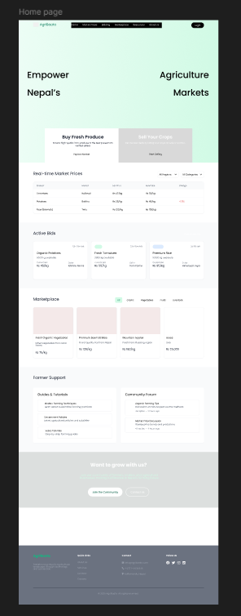

Figure 41 Homepage Low Fidelity

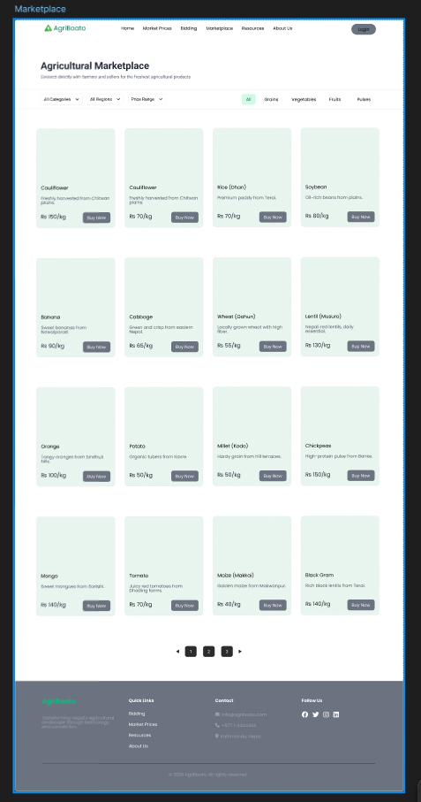

Figure 42 Marketplace Low Fidelity

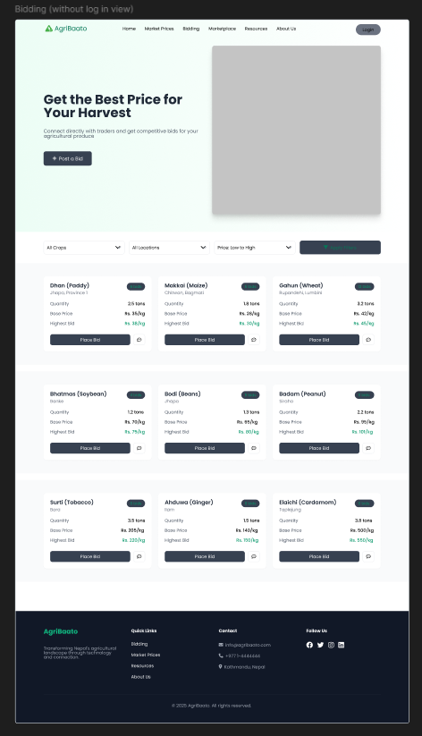

Figure 43 Bidding Low Fidelity

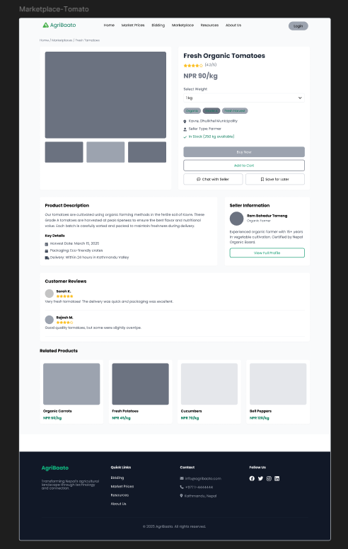

Figure 44 Marketplace Low Fidelity

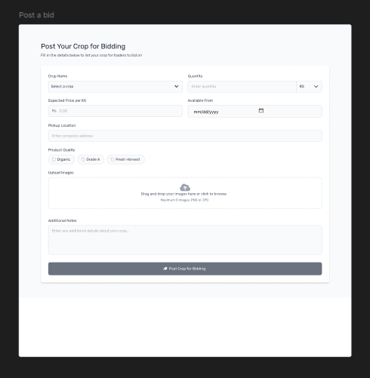

Figure 45 Post a bid Low Fidelity

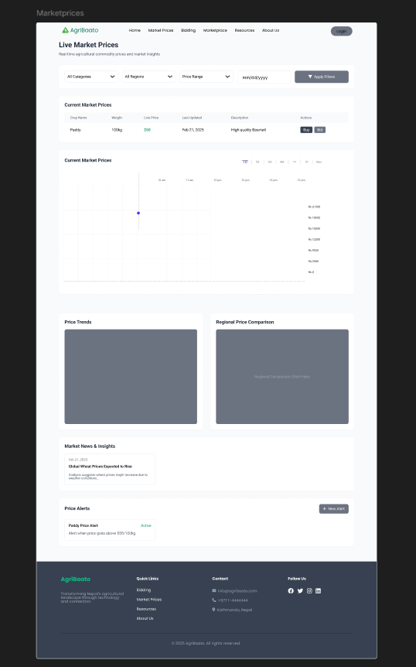

Figure 46 Marketplaces Low Fidelity

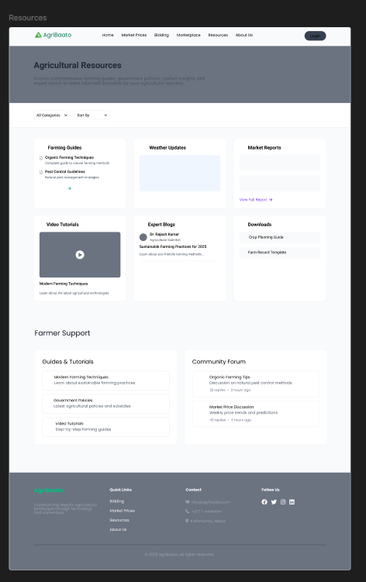

Figure 47 Resources Low Fidelity

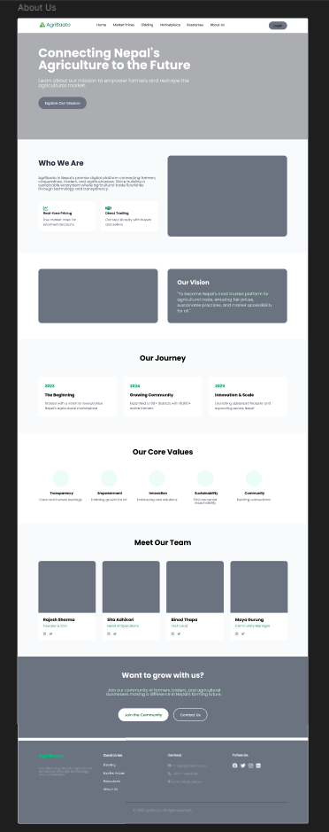

Figure 48 About us Low Fidelity

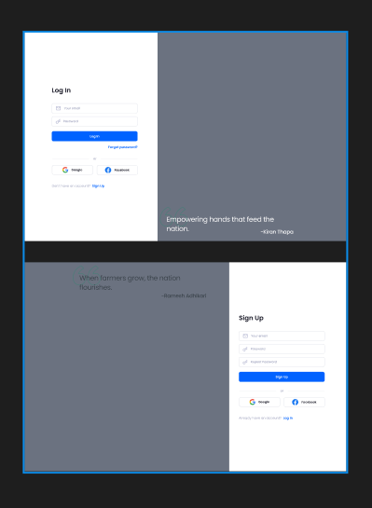

Figure 49 Sign in Low Fidelity

### High Fidelity

Colors, font, iconography, and real content are all used in high-fidelity mockups to represent branding. These designs capture the AgriBaato platform's final appearance and feel. Interactivity features including buttons, cards, and forms were stylized to improve clarity and engagement. Realistic material and visuals were used to closely emulate the user experience.  
  
These mockups were used for prototyping and user testing in order to collect final feedback prior to development. In the PC version, all pages were built to focus solely on one breakpoint.

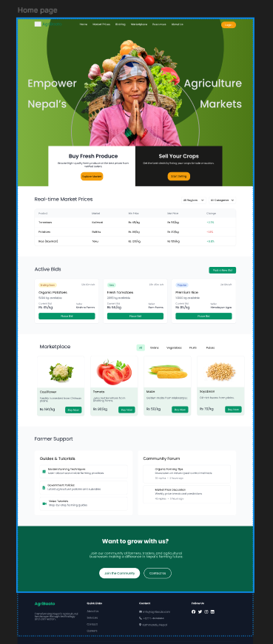

Figure 50 Home Page High Fidelity

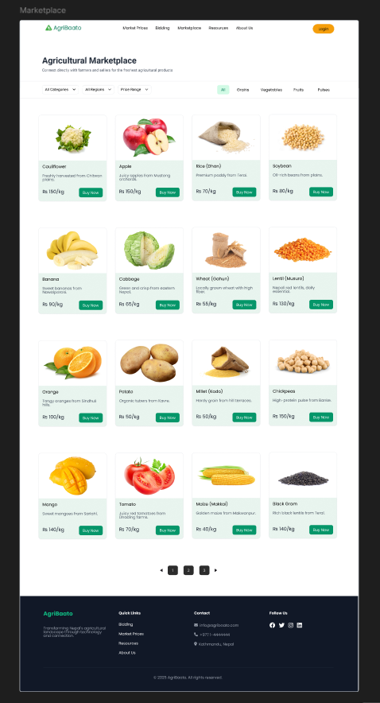

Figure 51 Marketplaces High Fidelity

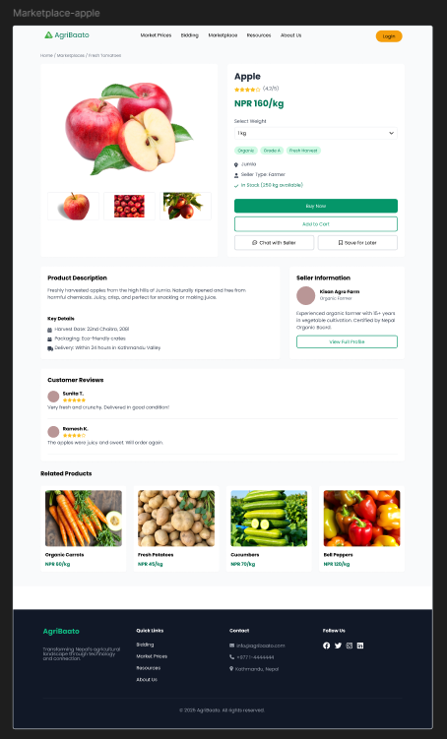

Figure 52 Marketplace High Fidelity 2

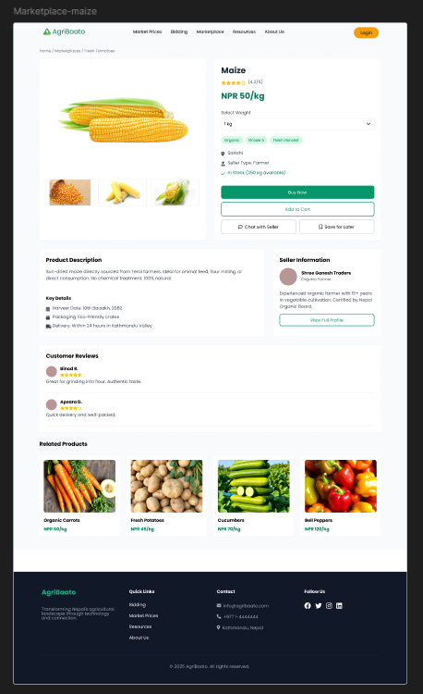

Figure 53 Marketplace High Fidelity 3

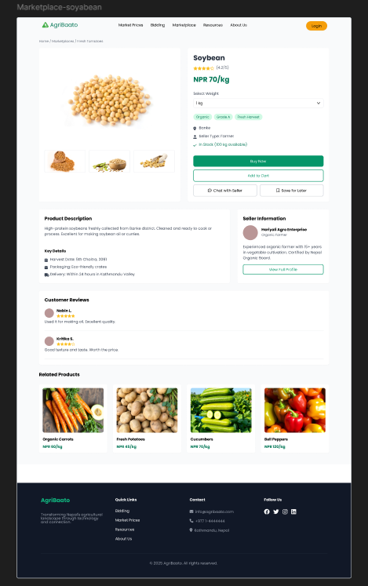

Figure 54 Marketplace High Fidelity 4

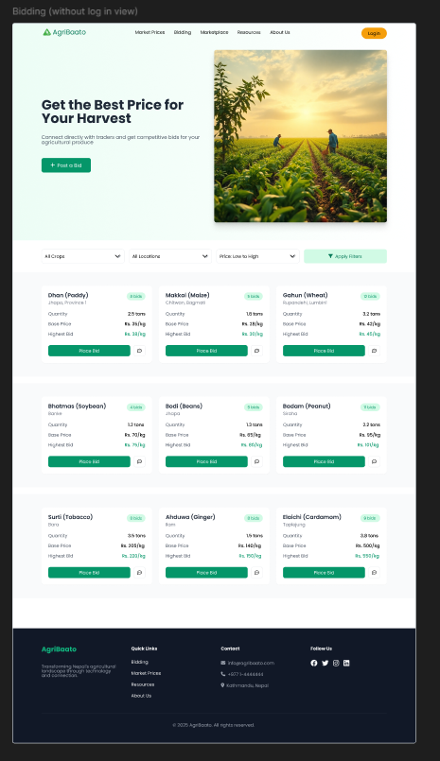

Figure 55 Bidding Page

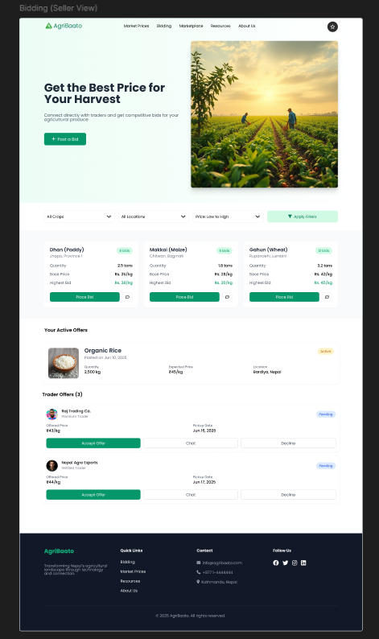

Figure 56 Bidding Page (Seller view)

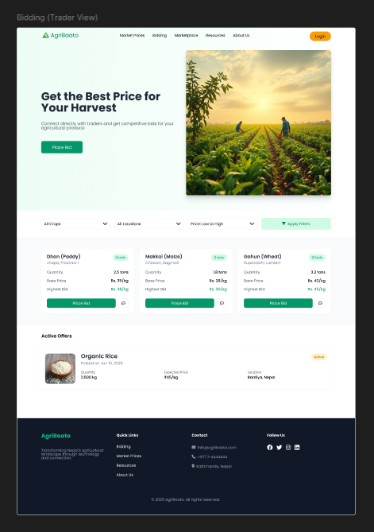

Figure 57 Bidding Page (Trader View)

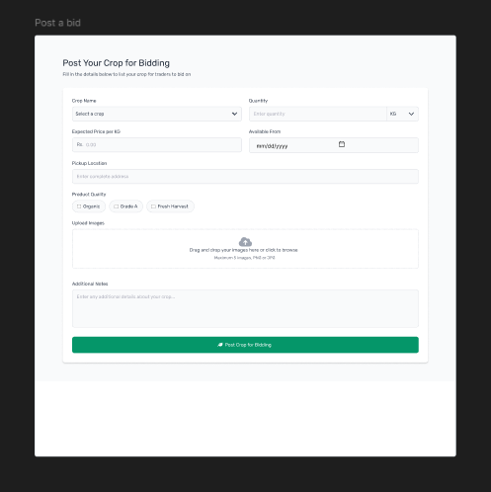

Figure 58 post a bid

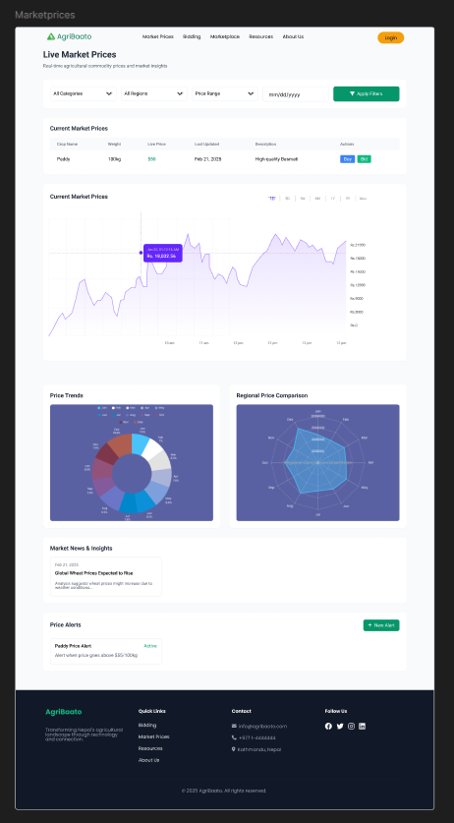

Figure 59 Marketprices high fidelity

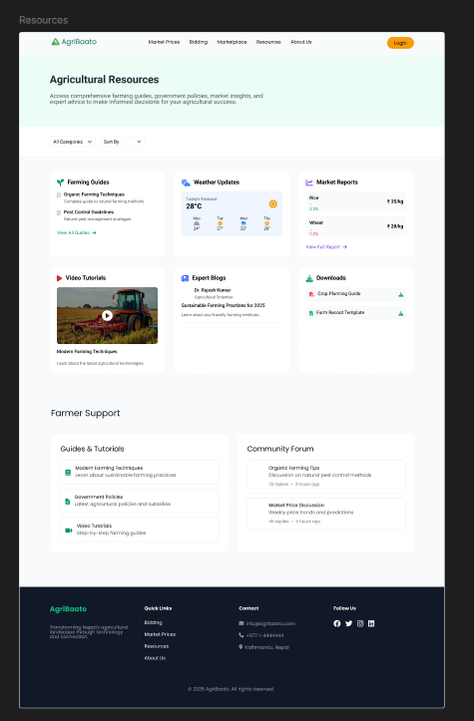

Figure 60 resources high fidelity

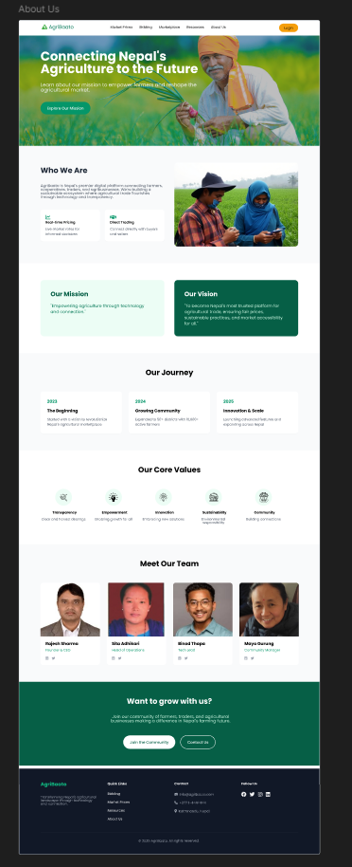

Figure 61 About Us High Fidelity

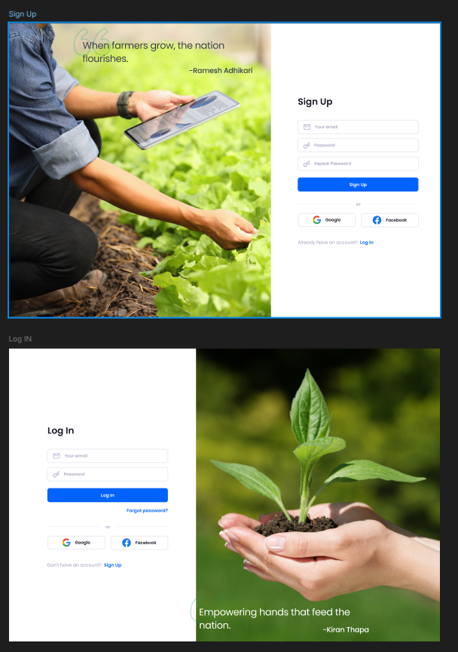

Figure 62 SignIn / LogIn

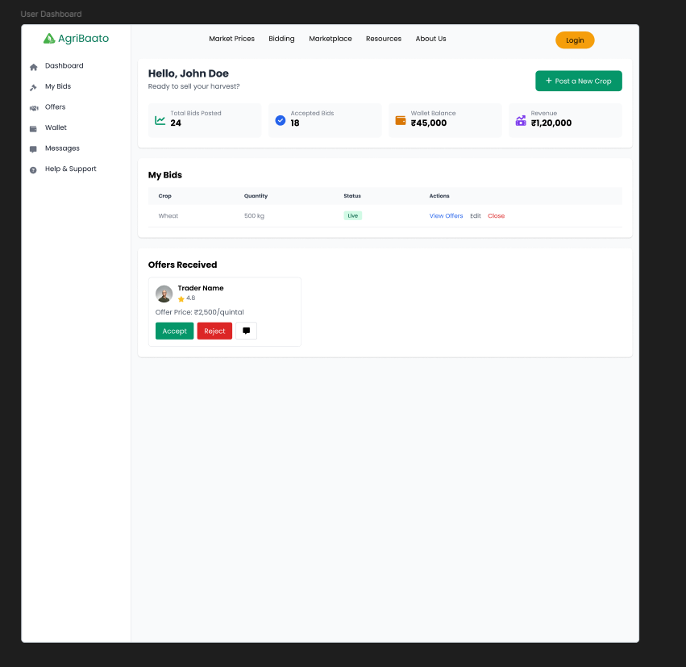

Figure 63 Dashboard High Fidelity

## Phase 5 – Prototyping

A functional prototype appeared using Figma after finalizing our detailed mockups. Users and stakeholders could see how the system worked during product flow through this prototype. Our team made navigation buttons and purchase buttons workable alongside dropdown menus and data input forms to develop platform simulation.

Our prototype served to do the following:

Test user traversal paths and system functions before programming begins.

Ask actual product users to test your system and give you, their response.

Show stakeholders the nearly complete base of the system before proceeding.

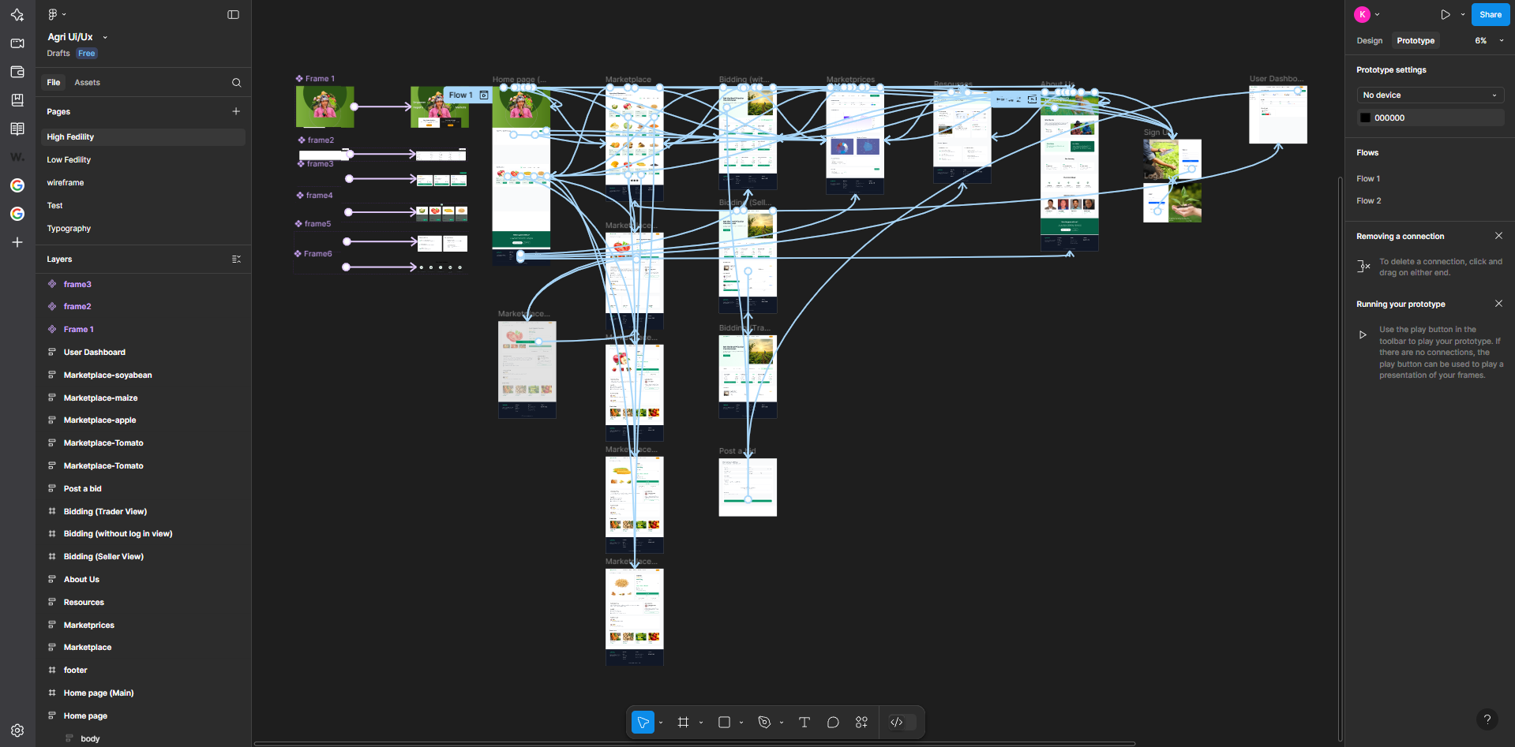

Figure 64 Prototyping

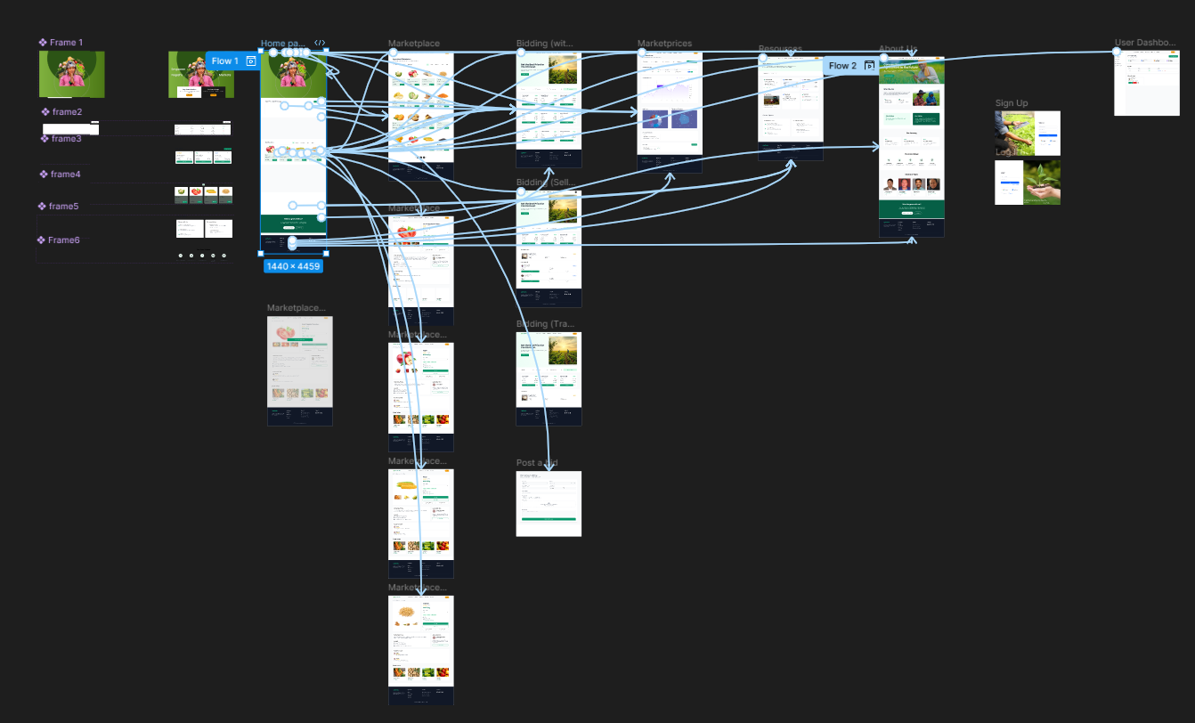

Figure 65 Prototyping 2

# User Testing and Findings

A user testing session with the prototype was carried out to assess usability. A Google Form was used to collect qualitative and quantitative input from 30 people, including potential farmers, dealers, and regular users.

User Demographics

Our research used user types such as Farmer, Trader, General User along with age groups and digital experience to create precise market profiles.

Ease of Navigation

We tested if users could understand the platform's design structure and move freely throughout the pages including Home, Marketplace and Product Detail.

Clarity of Purpose

Our tests showed users' success in understanding the platform's mission and core features including the Bidding System and Marketplace Listings system.

Task Completion

Asked users about their ability to perform activities including setting crop listings, making bids, viewing price information and the signup process.

Visual Design & Branding

The test participants assessed whether the design-built trust looked modern yet simply.

Content Clarity

The team tested how users can understand important text areas including buttons plus product labels and body text alongside call-to-action elements.

Functionality Feedback

People told us about their experience using the platform's main features such as real-time prices, product filters and profile dashboards.

Responsiveness & Performance

If desired, you can test how fast and responsive your design performs. This feedback should be tested after development is completed.

Suggestions for Improvement

A run-through question which lets users reveal what programs or sections they want added to our product's updates.

Overall Satisfaction

At the end the survey asked users to rate our platform and indicate if they would use or recommend it to others.

## Survey Result

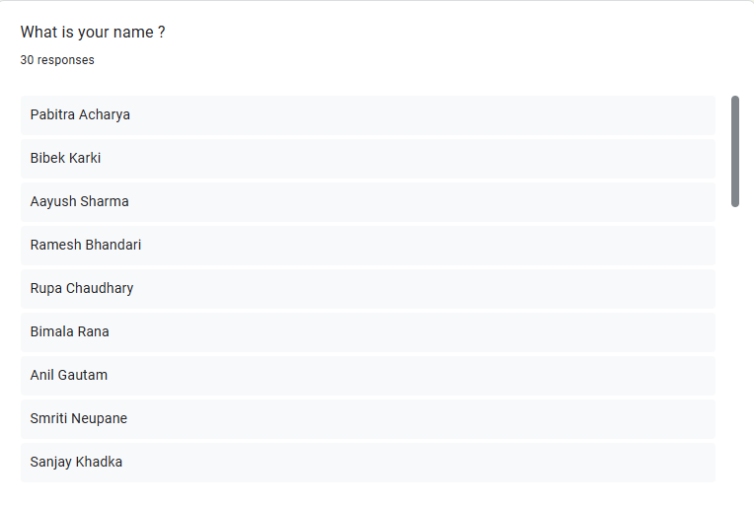

Figure 66 Survey Responses Name List

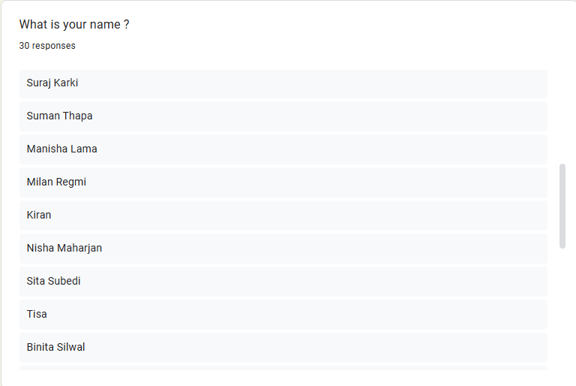

Figure 67 Survey Responses Name List 2

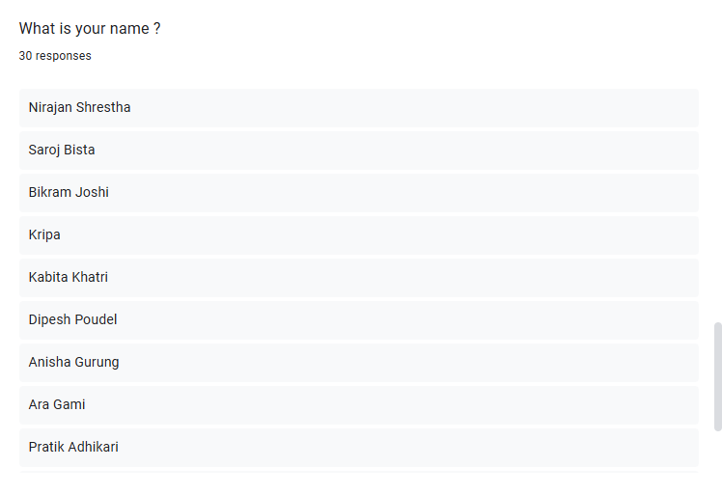

Figure 68 Survey Responses Name List 3

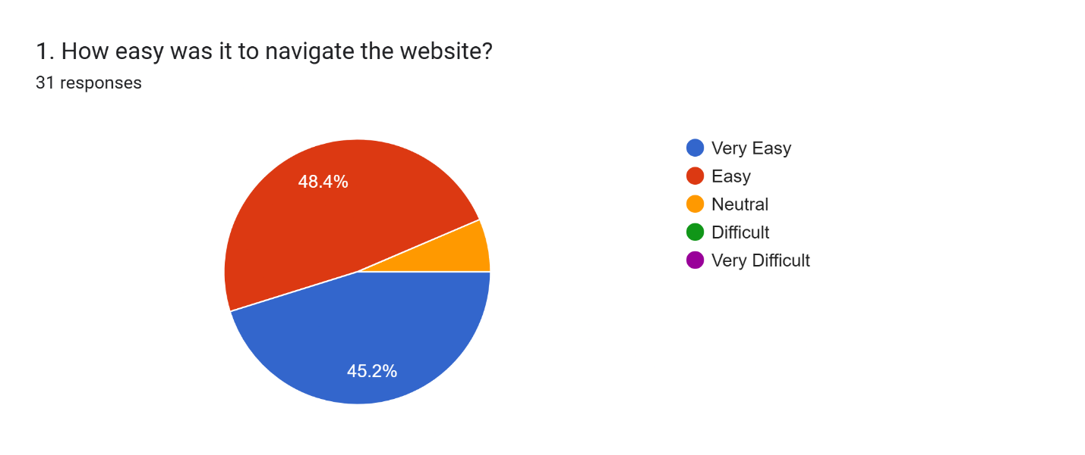

Figure 69 Questionnaire 1

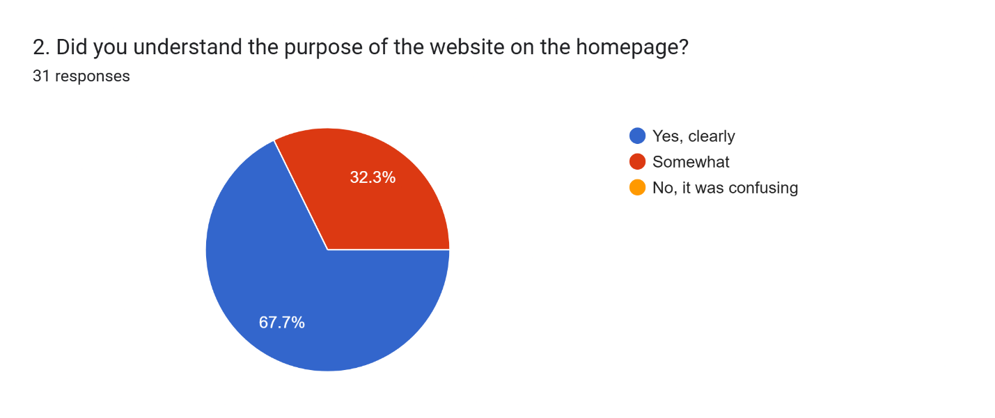

Figure 70 Questionnaire 2

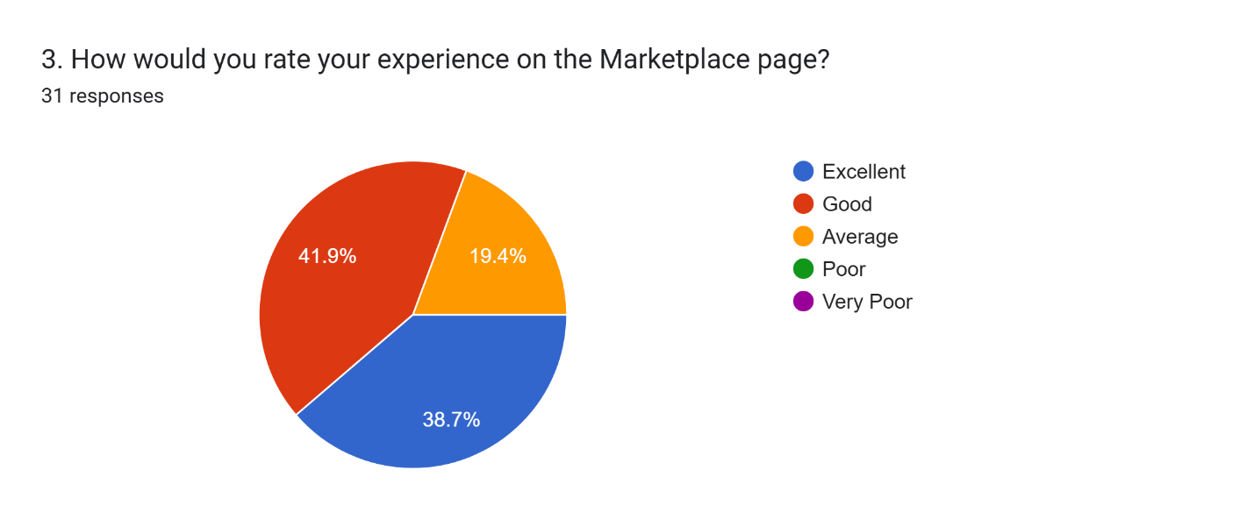

Figure 71 Questionnaire 3

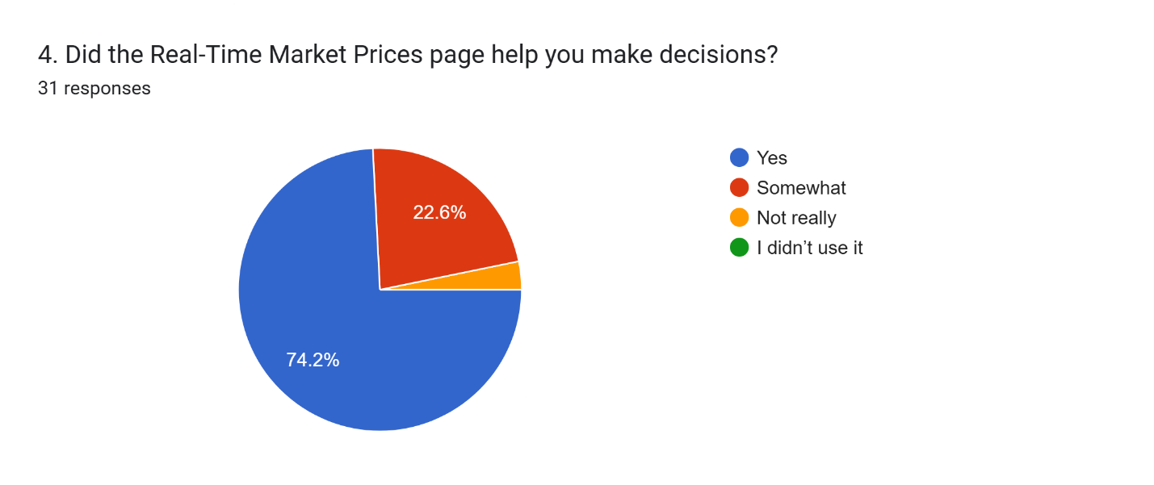

Figure 72 Questionnaire 4

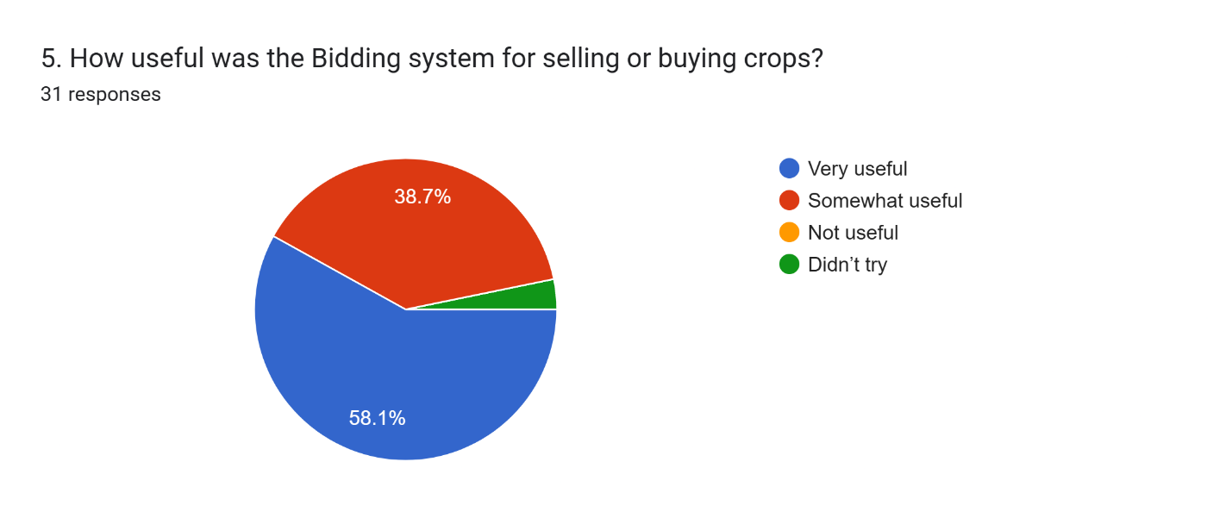

Figure 73 Questionnaire 5

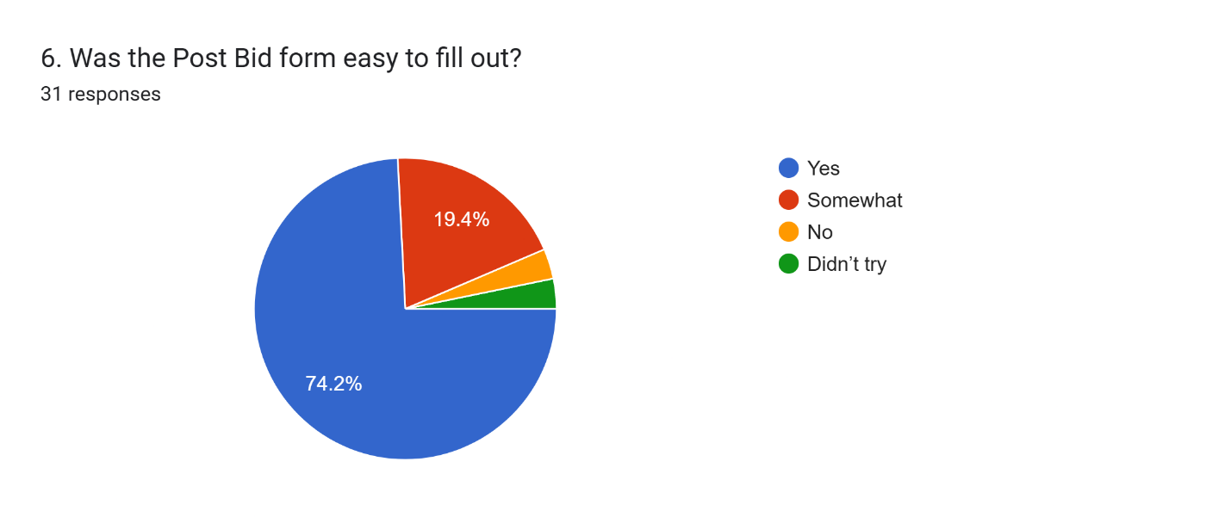

Figure 74 Questionnaire6

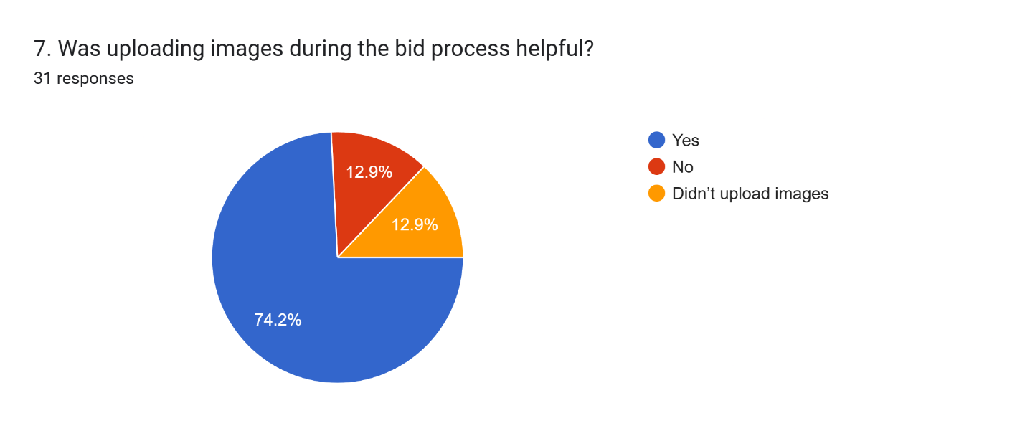

Figure 75 Questionnaire 7

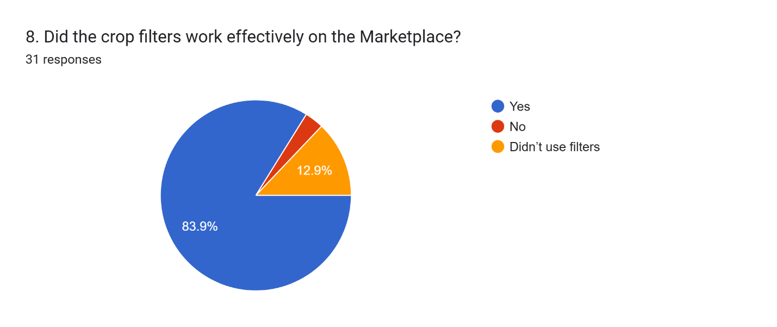

Figure 76 Questionnaire 8

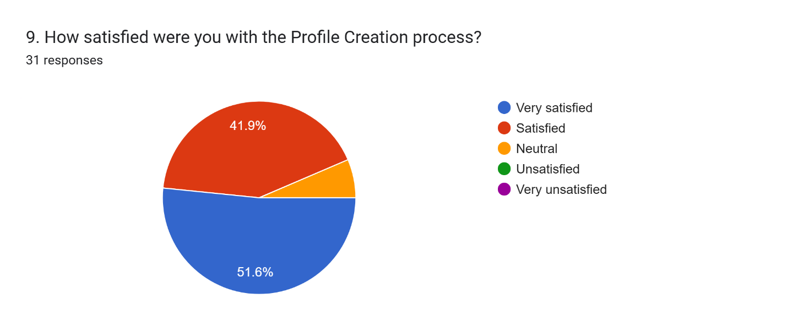

Figure 77 Questionnaire 9

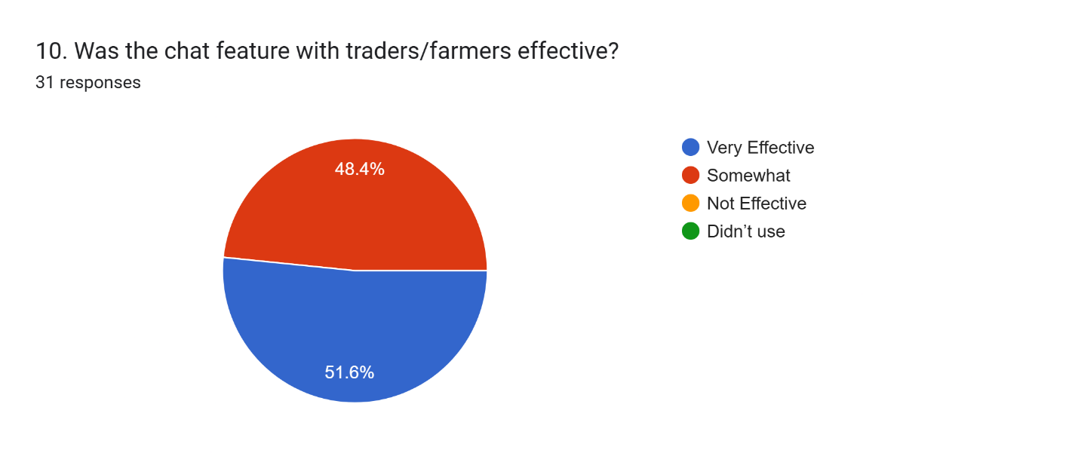

Figure 78 Questionnaire 10

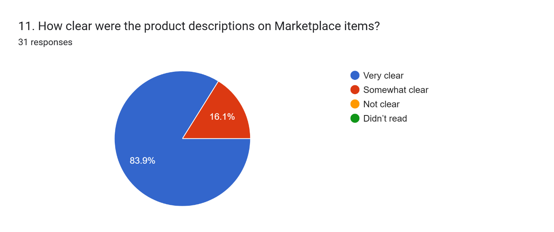

Figure 79 Questionnaire 11

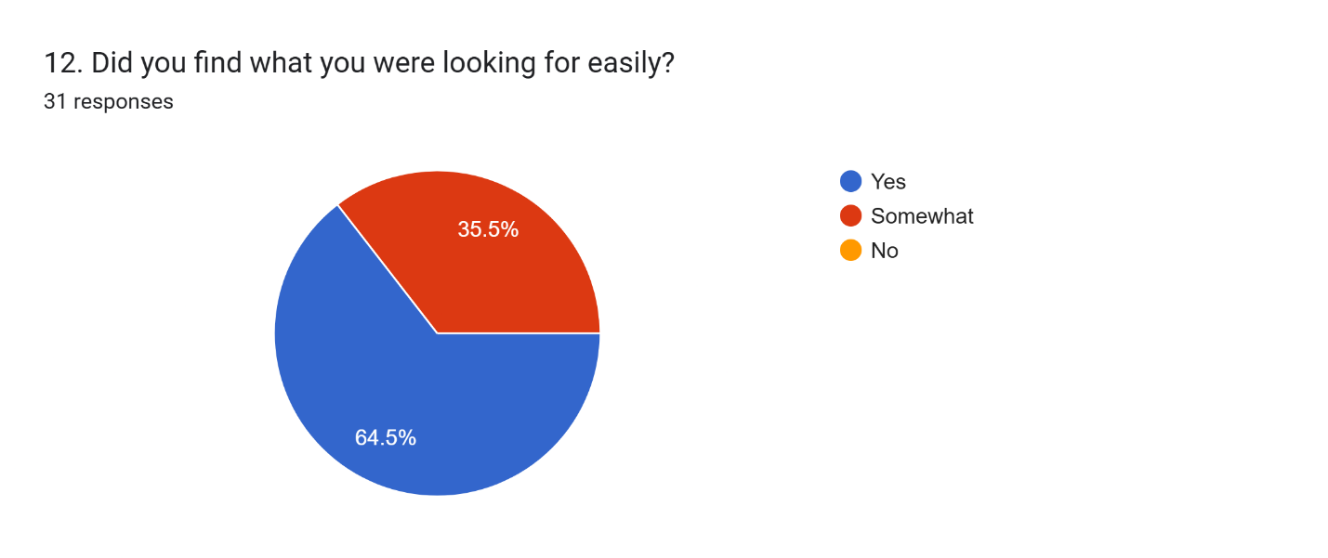

Figure 80 Questionnaire 12

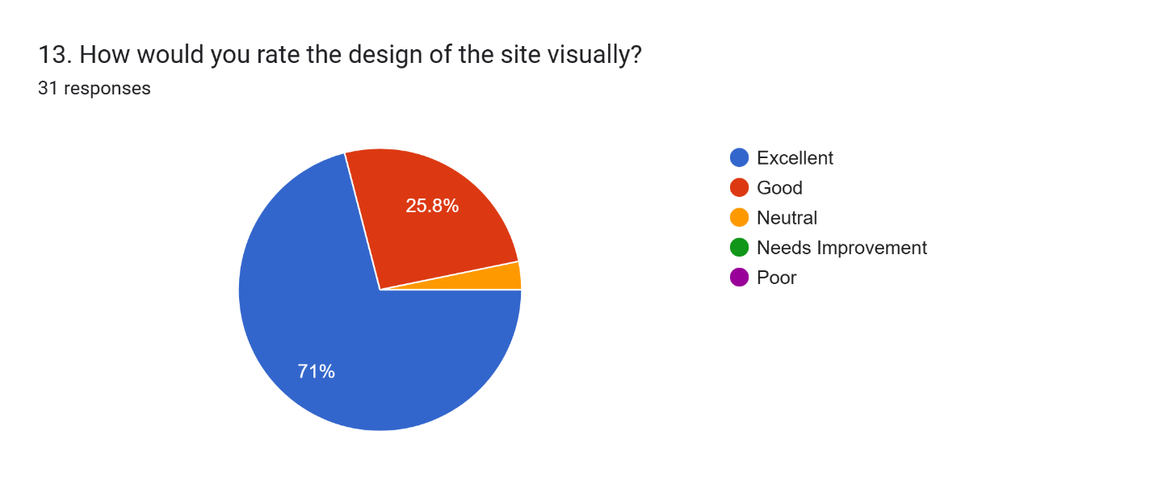

Figure 81 Questionnaire13

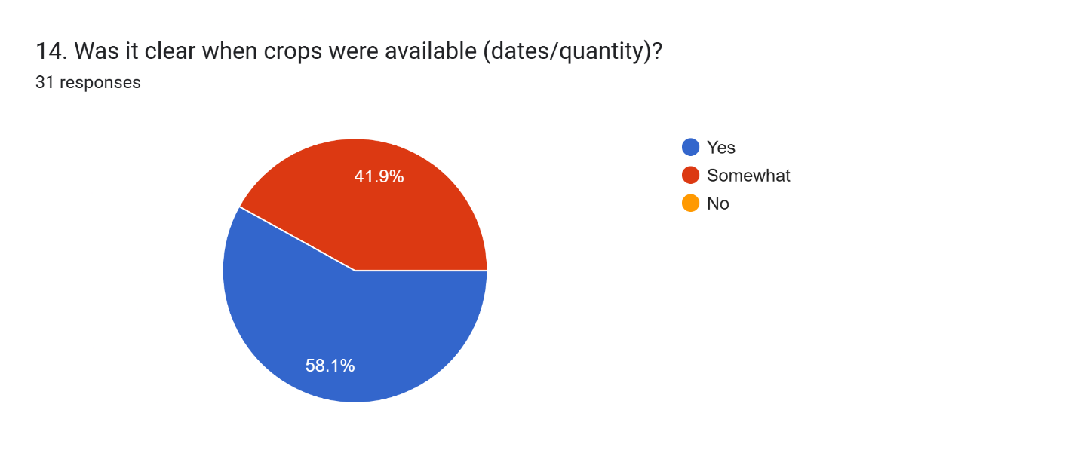

Figure 82 Questionnaire 14

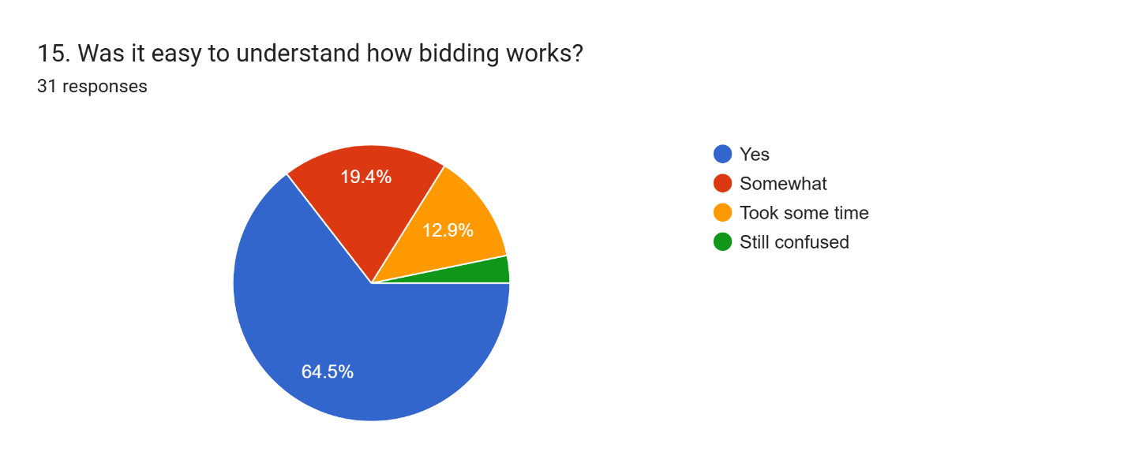

Figure 83 Questionnaire 15

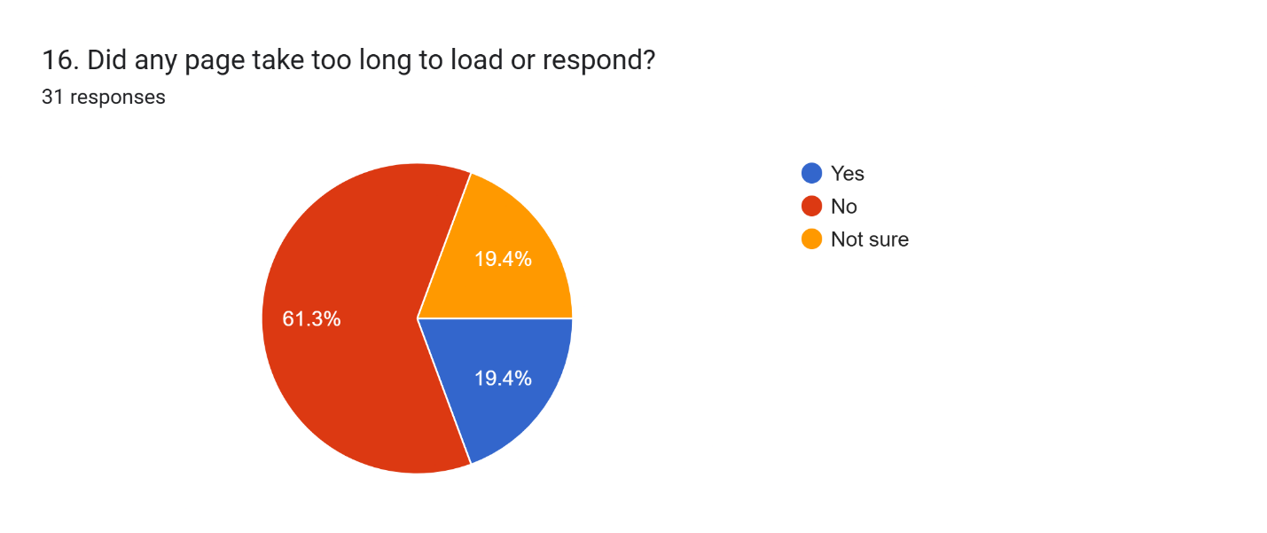

Figure 84 Questionnaire 16

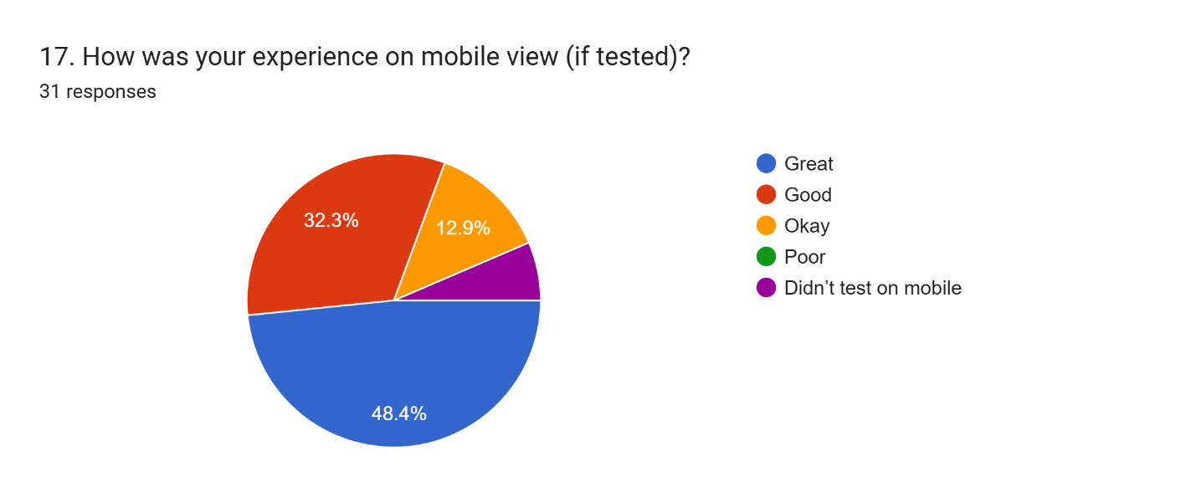

Figure 85 Questionnaire 17

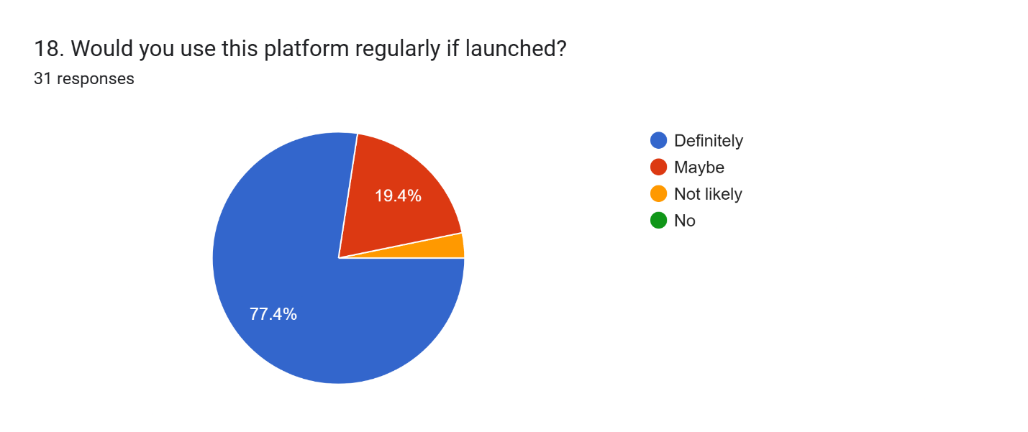

Figure 86 Questionnaire18

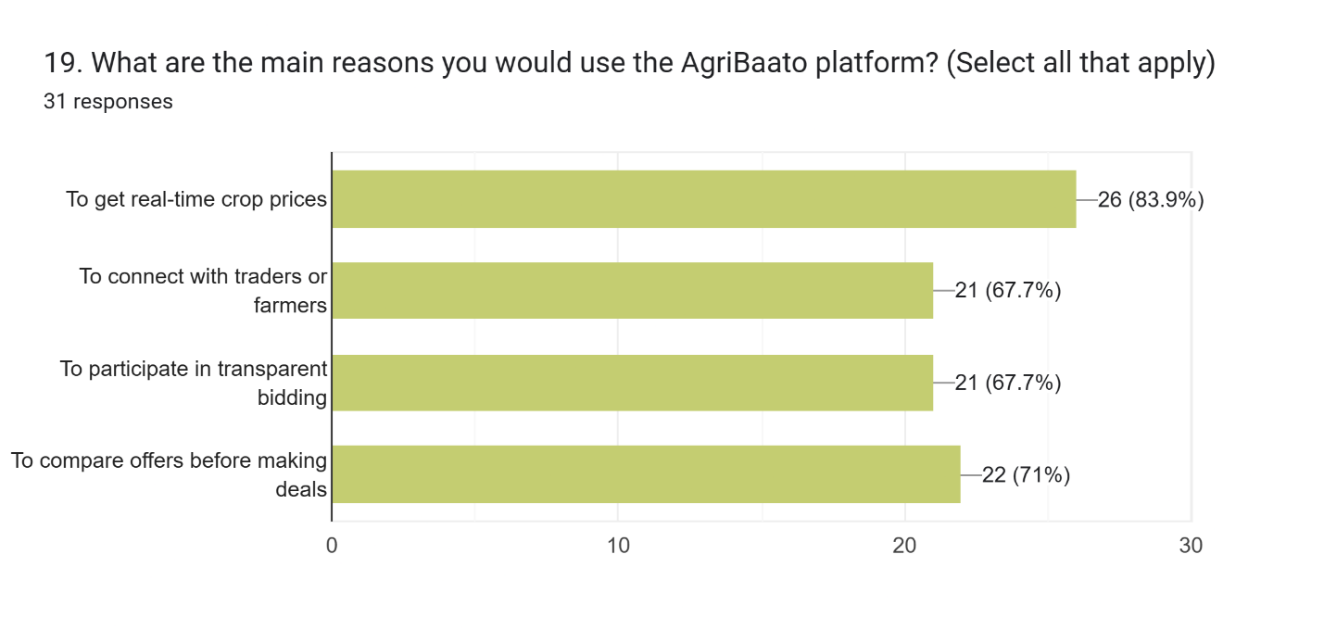

Figure 87 Questionnaire 19

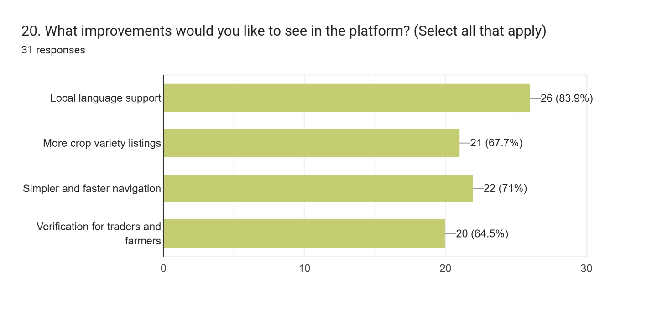

Figure 88 Questionnaire 20

## Survey Insights

General Navigation & Understanding

Most users found your site navigation easy at 93.6% showing your design works well for everyone. Every user understood what the website does from the homepage including 67.7% who understood straight away.

Marketplace Experience

The online market platform provides a good to excellent experience for 80.6% of users who find their product display and user interaction useful. The latest results show that 83.9% of customers think your description structure provides excellent information clarity. A large part of our users (64.5%) found their desired search results quickly yet 35.5% faced difficulty which shows us we need to update our search and filter interface. 83.9% confirmed crop filters worked well.

Real-Time Market Prices & Bidding

The system shows current market prices while users take real-time actions. Most users (74.2%) confirmed that when prices update in real-time, they can better understand market values for their decisions. The auction system proved valuable to 96.8% of users and 64.5% found it easy to use though 12.9% still struggled to make sense of it. Most participants confirmed that filling out the post-bid form was straightforward while 74.2% agreed uploading images supported their bidding process.

User Features (Profiles & Chat)

Our system offers user features and chat services for profile setup and messaging. Most users reached completion of the Profile Creation process with strong contentment at 93.5%. All users agreed that the chat feature was useful for chatting in the platform's design.

Design & Visual Appeal

Our visual design elements received high marks with 96.8% of users rating them excellent or good. The crop information provided did not appear clearly to the survey participants because 58.1 percent rated it unclear and 41.9 percent found it somewhat unclear. Adding better visual displays may help in this area.

Technical Performance

The measurements reveal slow-loading pages affected 19.4% of participants since 61.3% did not have this issue. Despite the positive ratings of almost half the users, the remaining users experienced problems with personal device performance. As this device operates on a desktop platform our findings target mobile potential for development.

Platform Use & Feature Value

Our survey results show that 77.4% of respondents want to use our platform when it launches, which proves that customers need this solution.

Users were most attracted to: Real-time crop prices (83.9%) Transparent bidding (67.7%) Efficient crop trading (71%) Comparing offers (67.7%)

Suggested Improvements

Top feature requests include: More crop variety listings (83.9%), Simpler, faster navigation (67.7%) Local language support (71%) Verified user profiles for trust (64.5%)

# Evaluation

## A person sitting against a wall AI-generated content may be incorrect.Self- Evaluation

Figure 89 Self Evaluation

I designed and built AgriBaato's desktop prototype based on basic UX principles to help both farmers and traders solve their specific real-life challenges. farmers and traders. By using UX's five design elements I kept everything clear at every design phase during this project.

Although my design fulfilled all necessary functions, I recognize that I should have dedicated more resources to mobile optimization and accessibility work. Our research helped us learn effective ways to make bidding and product viewing easier by updating our design. Despite time management issues during wireframing and high-fidelity design we finished all essential tasks within the project deadline.

My future work will involve seeking user feedback sooner during prototyping than testing with a wider range of people. My work improved my knowledge of user-centered approaches and interface creation while adding to my document preparation skills.

## Third-Party Evaluation

Abhinav Devkota

Figure 90 Abhinav Devkota

Abhinav thought the desktop form of AgriBaato worked easily for experts to use. Because of his IT knowledge he appreciated the well-organized wireframe design. He enjoyed the market exchange area most because farmers and buyers conduct direct open transactions. According to Ibrahim, the interface could work better with text chats that update in real time and dashboard filters that show information more clearly. He approved the platform because it works well for users with minimum digital understanding.

Asuka Bhattachan

Figure 91 Asuka Bhattachan

The design structure of the interface impressed Asuka. The user interface impressed Asuka with its modern design, clean formatting, and appropriate spacing. As a design student she saw that putting buttons and colors together made the interface look more inviting. She suggested teaching new users about the website's basic functions with a tutorial that explains bidding, crop upload, and dashboard navigation. She suggested making some parts easier to see for people with vision differences.

Anush Shakya

Figure 92 Anush Shakya

Anush's farming background and business experience made him like seeing recent market rates and being able to interact directly with bidders. He found that buyers can trust sellers because the platform lets them see competing offers plus talk with interested bidders directly. He appreciated seeing local farm crops added to the platform plus the opportunity to bid in bulk. He recommended including local languages plus making interface labels easier to understand for rural users. He wants developers to make mobile compatibility an essential part of upcoming platform updates.

# Conclusion

To sum up, the AgriBaato UI/UX design project effectively showcased the process of creating a digital platform specifically designed for Nepal's agricultural sector. The documentation offered a structured overview of every phase, from developing the initial concept to the final evaluation and reflection. The design incorporates several features, including real-time crop prices, bidding, user profiles, and a user-friendly marketplace—all of which are in line with the project's primary objectives. A clear direction for usability and functionality was established through competitor analysis, information architecture planning, and wireframing. Testing conducted by users and third parties yielded constructive responses as well as aspects needing enhancement, aiding in the polishing of the definitive prototype.

This coursework demonstrates how UX principles can be applied to address real-world challenges and underscores the significance of design thinking in creating impactful digital solutions for local communities and stakeholders in the agricultural sector.

# Bibliography

Geokrishi.farm. (2020). *Geokrishi - Digitalizing Agriculture in Nepal*. [online] Available at: <https://geokrishi.farm/> [Accessed 7 May 2025].

AgriWebb. (n.d.). *AgriWebb | Livestock Farm Management Software*. [online] Available at: <https://www.agriwebb.com/>.

Agribazaar.com. (2024). *Agribazaar*. [online] Available at: <https://www.agribazaar.com/>.

agrevolution.in. (n.d.). *DeHaat, From Seeds to Market | Online marketplace for farmers*. [online] Available at: <https://agrevolution.in/>

Kisannetwork.com. (2024). *Kisan Network - Smart Deals in your hand*. [online] Available at: <https://kisannetwork.com/>.

# Appendix

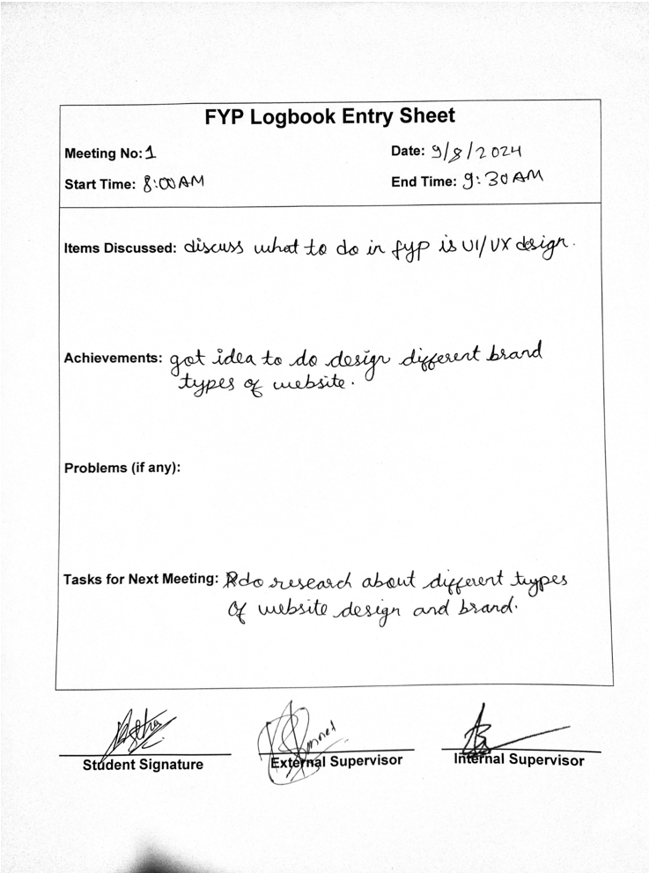

Figure 93 Log sheet 1

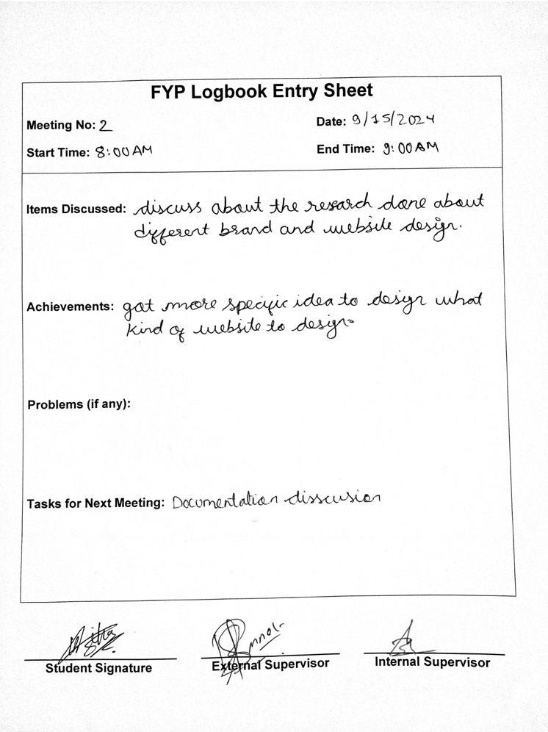

Figure 94 Log sheet 2

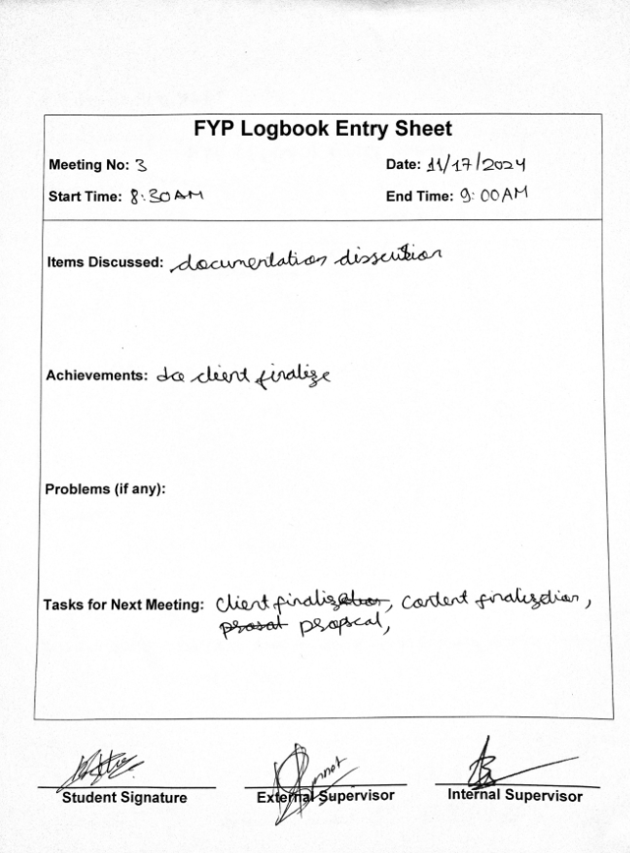

Figure 95 Log sheet 3

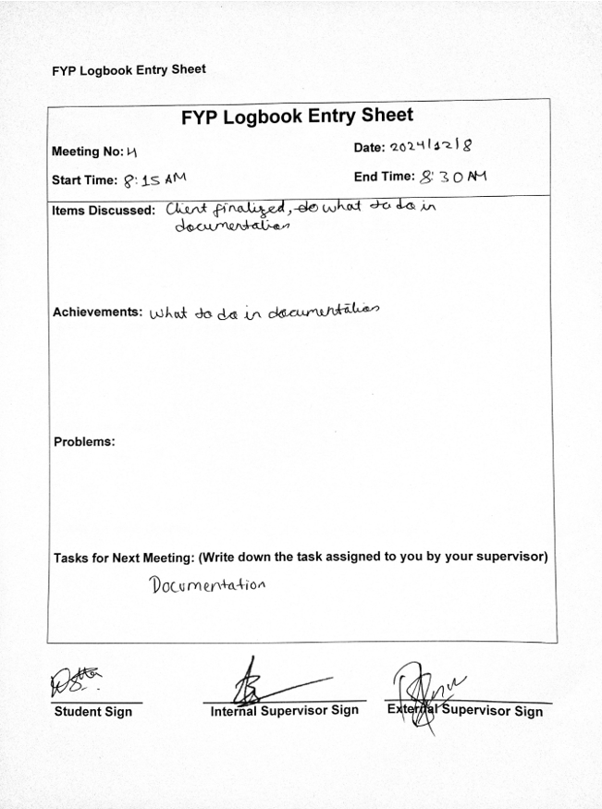

Figure 96 Log sheet 4

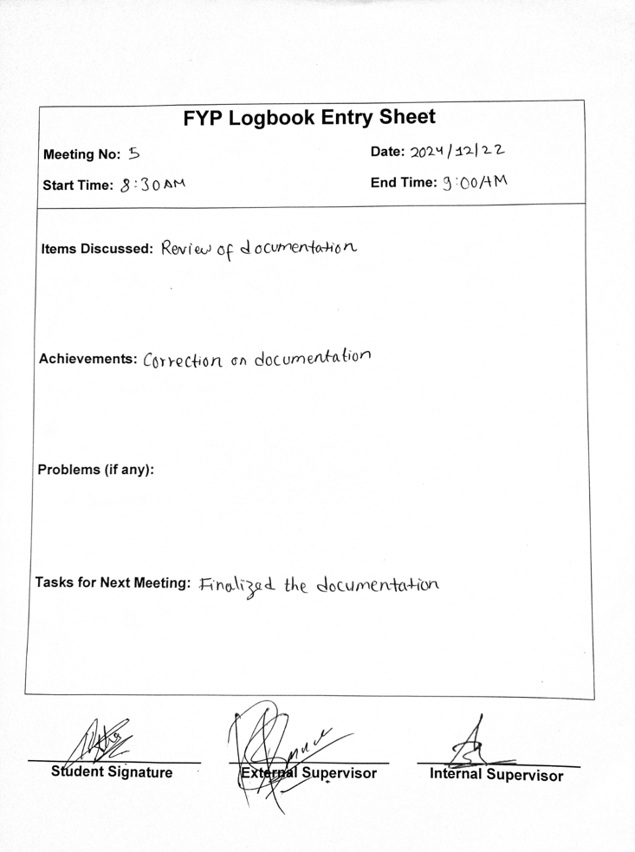

Figure 97 Log sheet 5

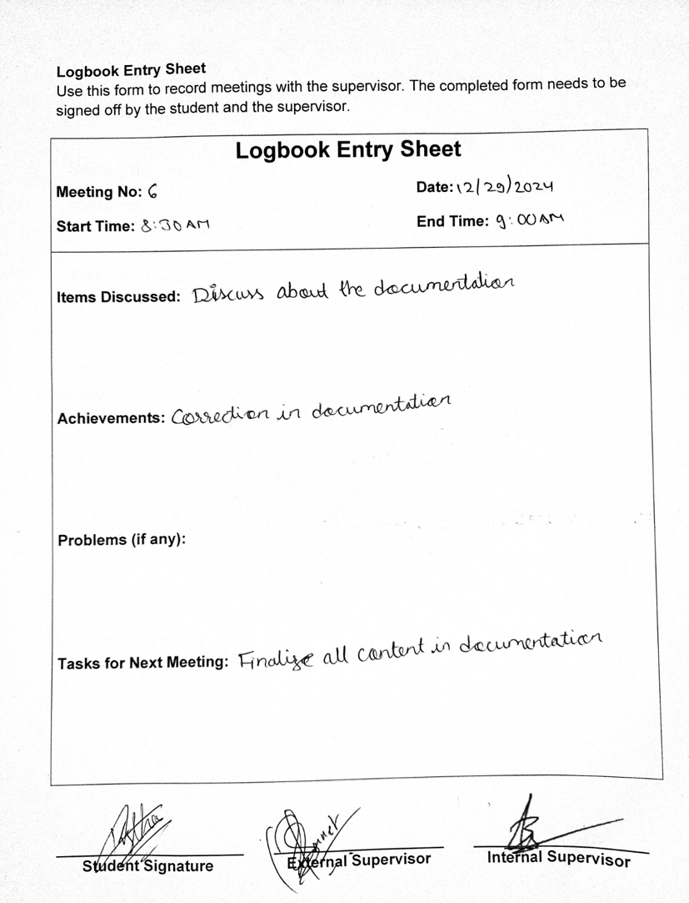

Figure 98 Log sheet 6

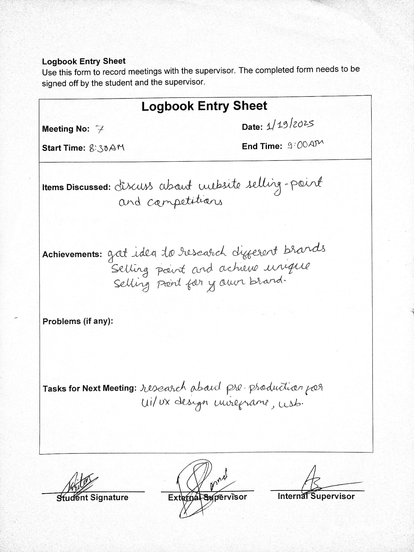

Figure 99 Log sheet 7

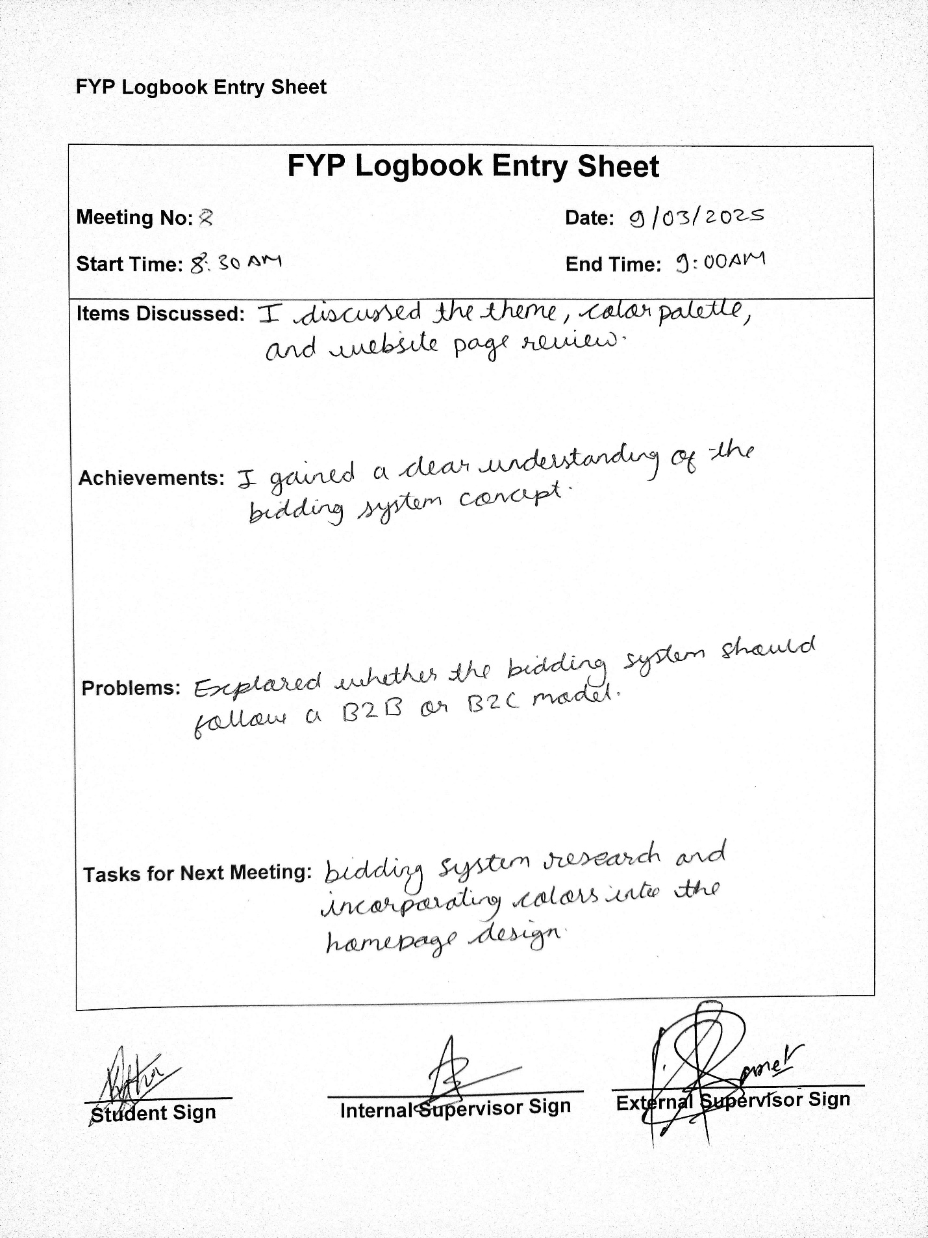

Figure 100 Log sheet 8

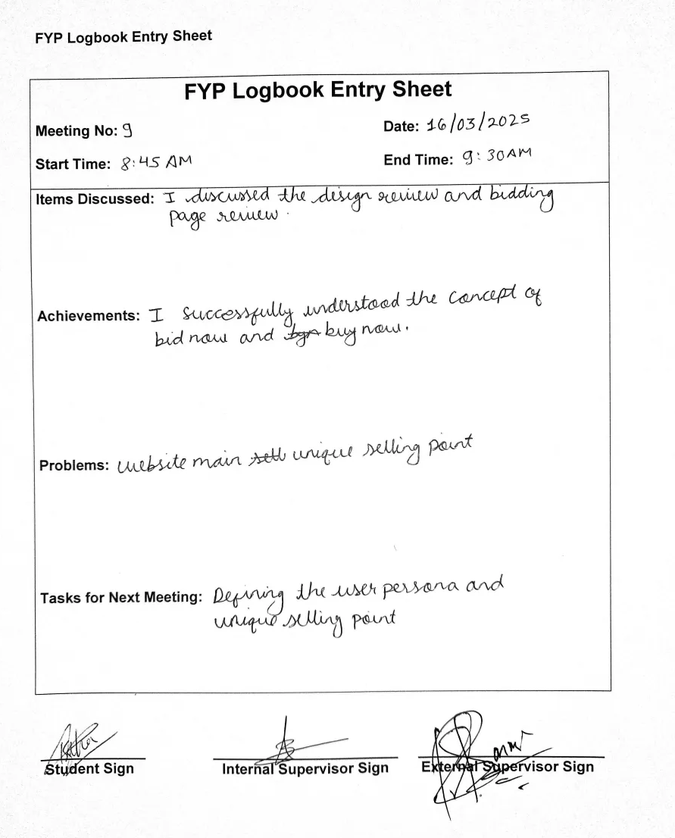

Figure 101 Log sheet 9

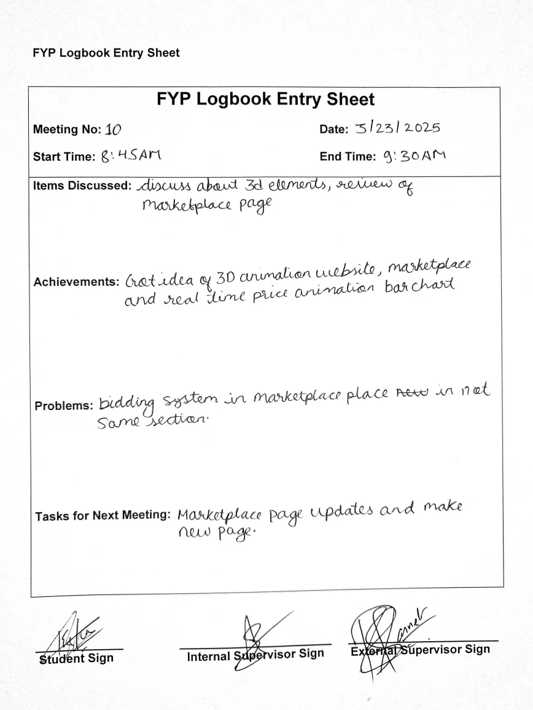

Figure 102 Log sheet 10

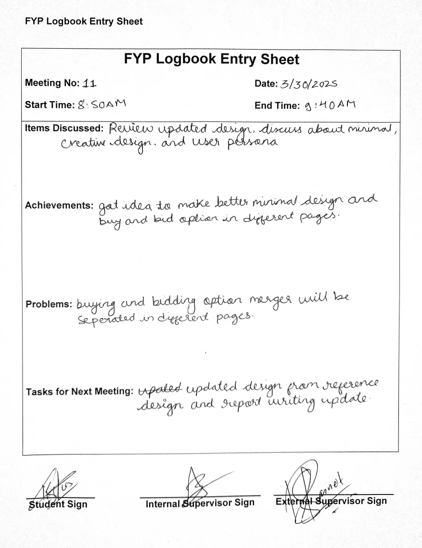

Figure 103 Log sheet 11

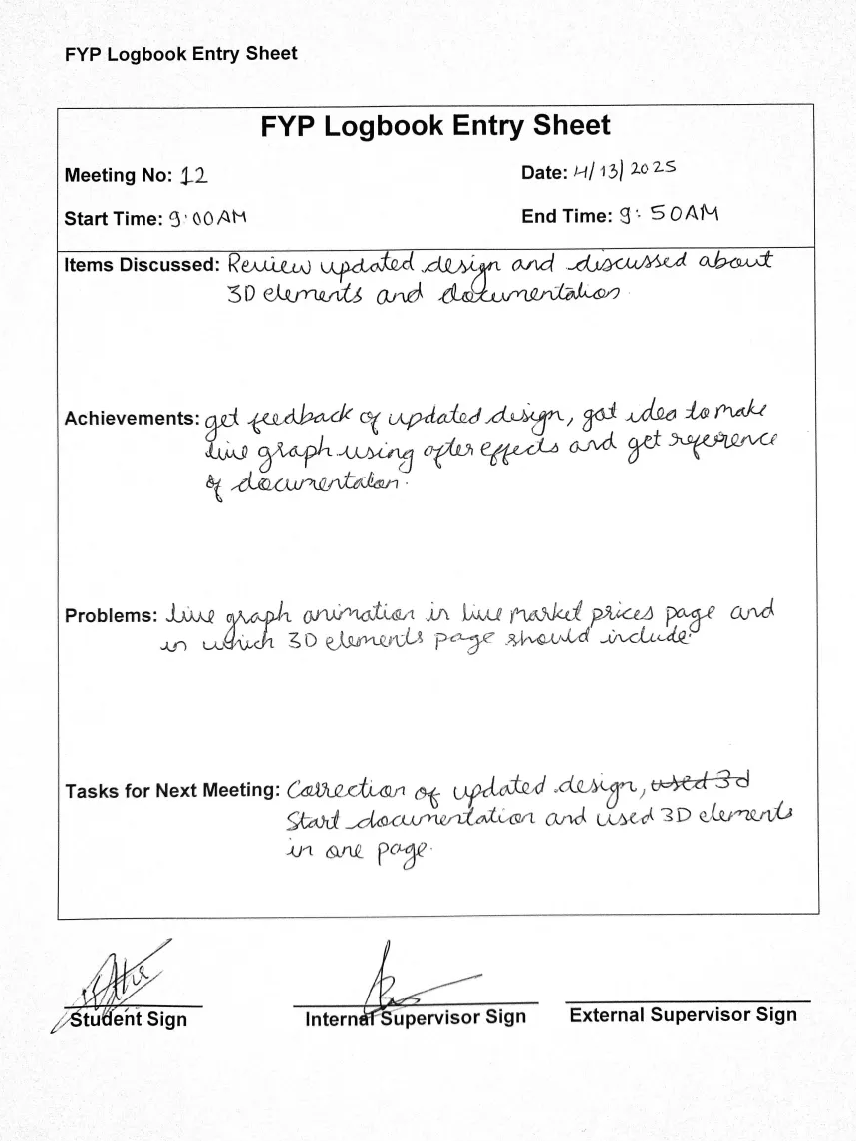

Figure 104 Log sheet 12